GoToMeeting connector for Creatio set-up guide.
1. Log in in your Google account

2. Open Google Developers API dashboard in browser and create new project. (https://console.cloud.google.com/apis/dashboard)
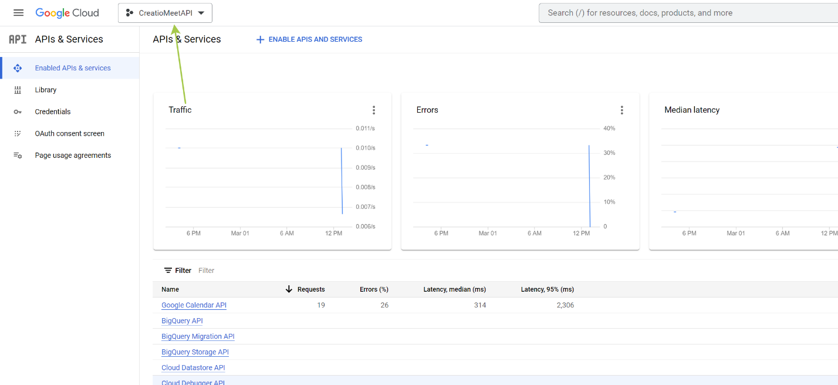
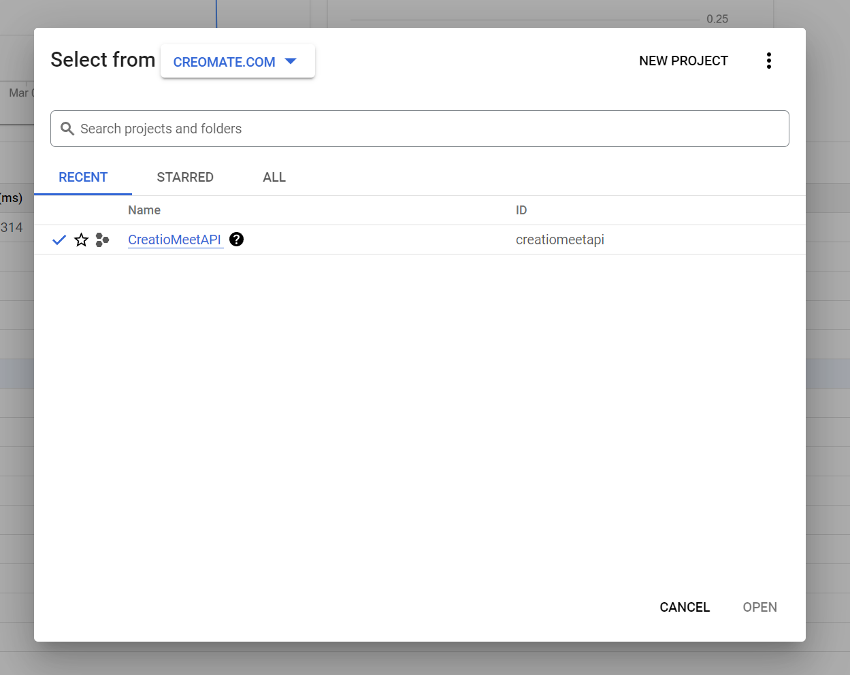
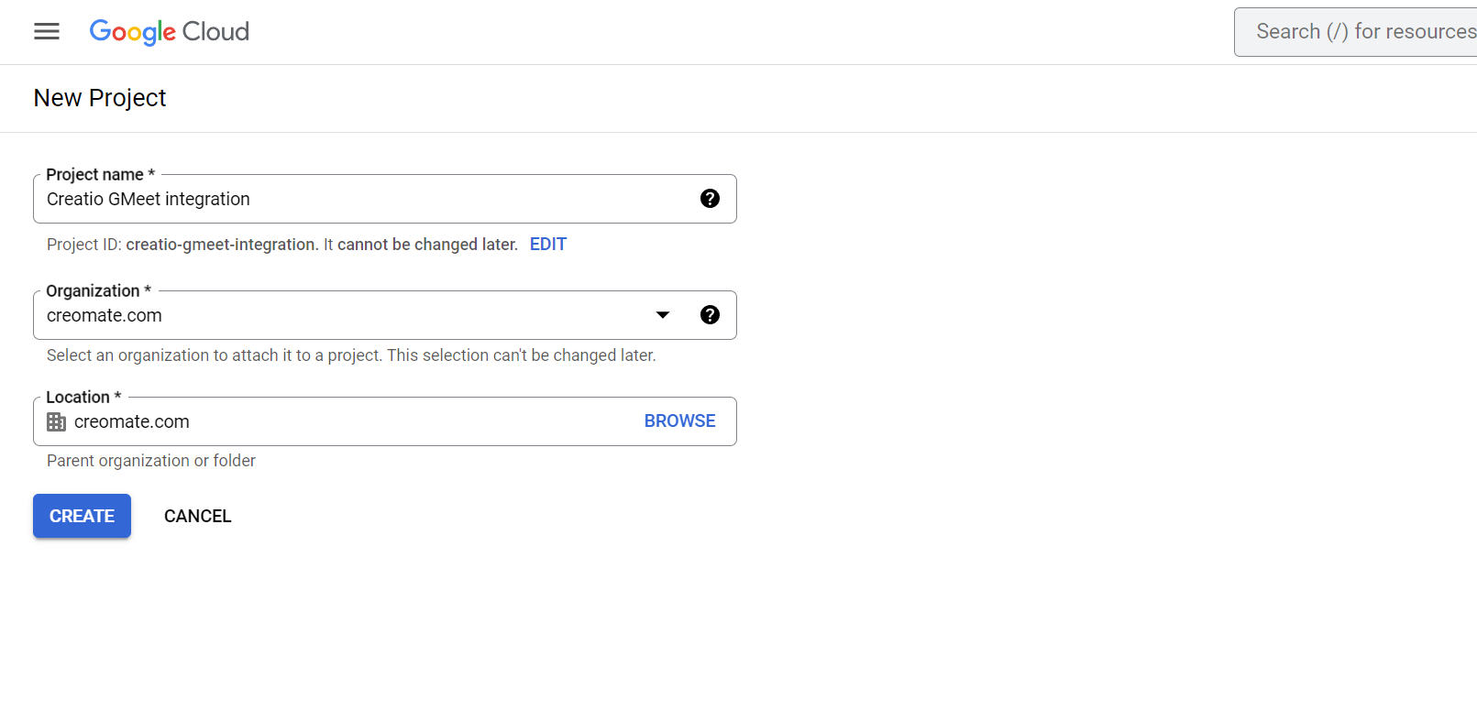
Set any project name and choose your organization.

3. Enable Google Calendar API for your project
Choose your new project and click at “Enable APIs and services” button.
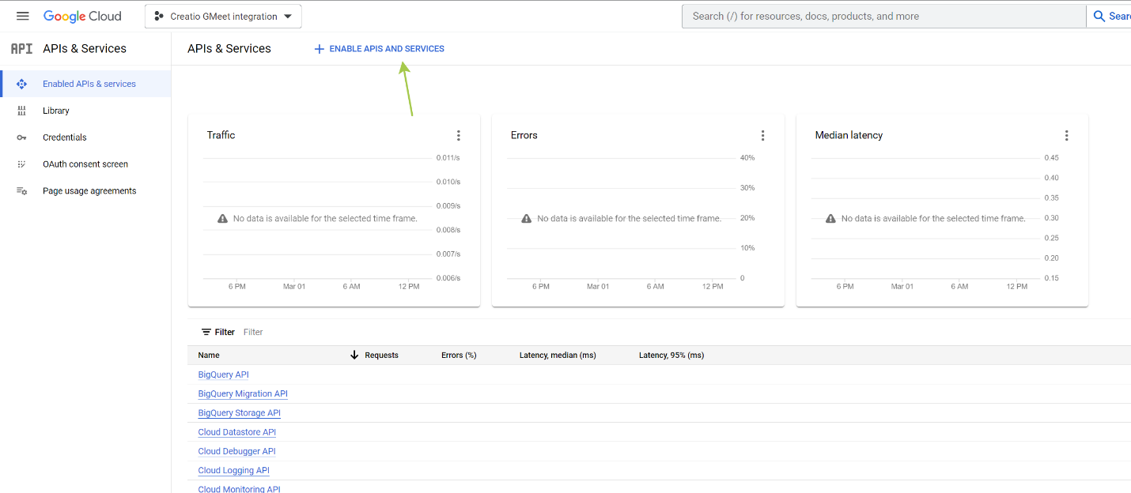
Find Calendar API, open it and click Enable.
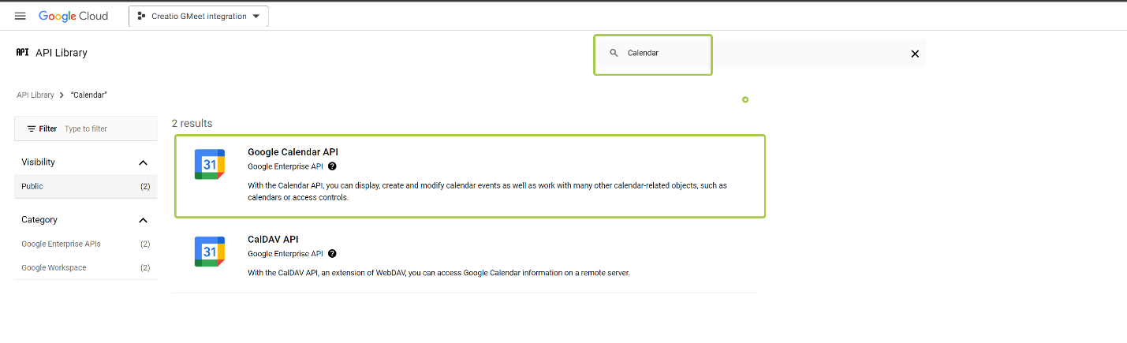
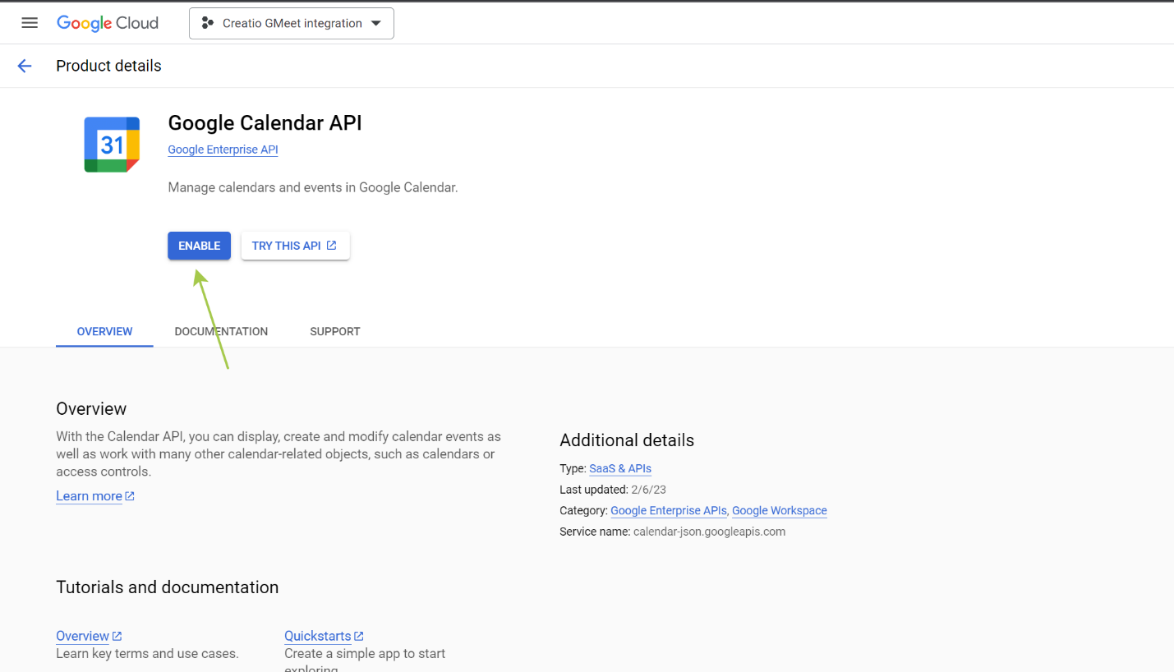

4. OAuth configuration
Open OAuth consent screen tab and choose Internal user type, then create.
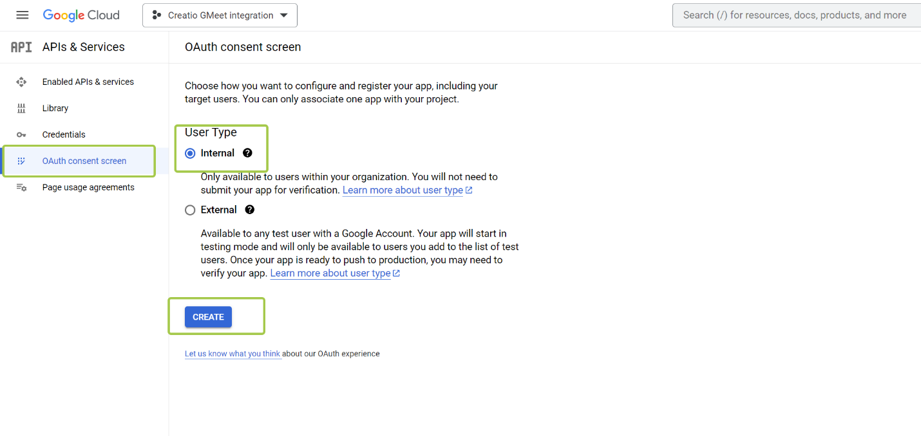

Fill app information (you can fill only required fields)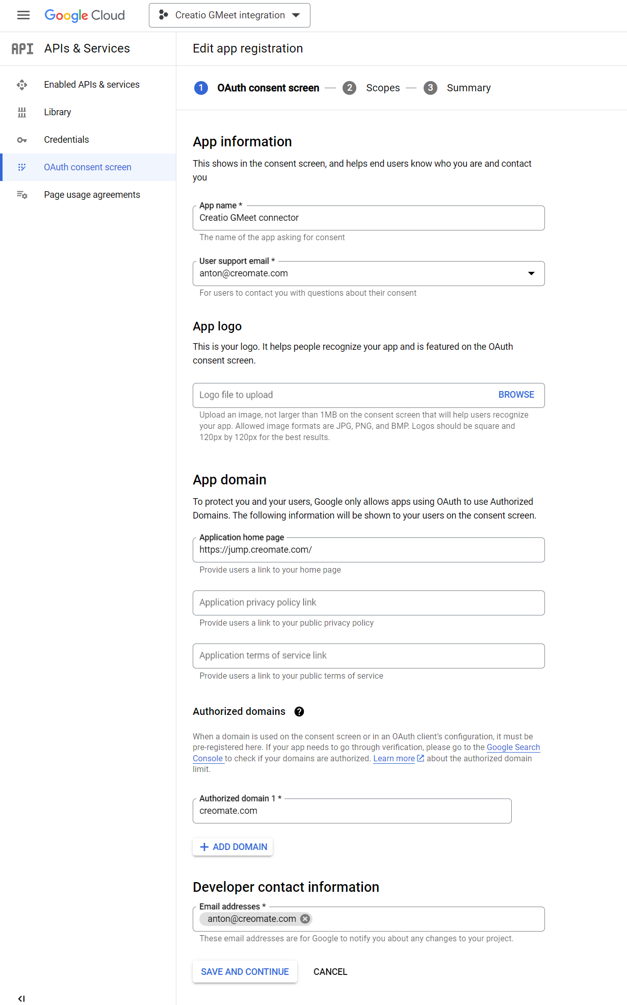

Click Save and Continue and then add Calendar API scope for application.
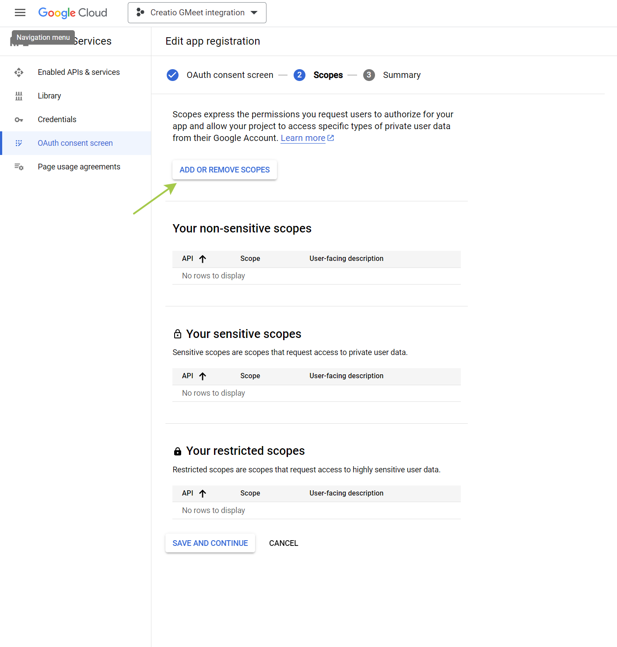
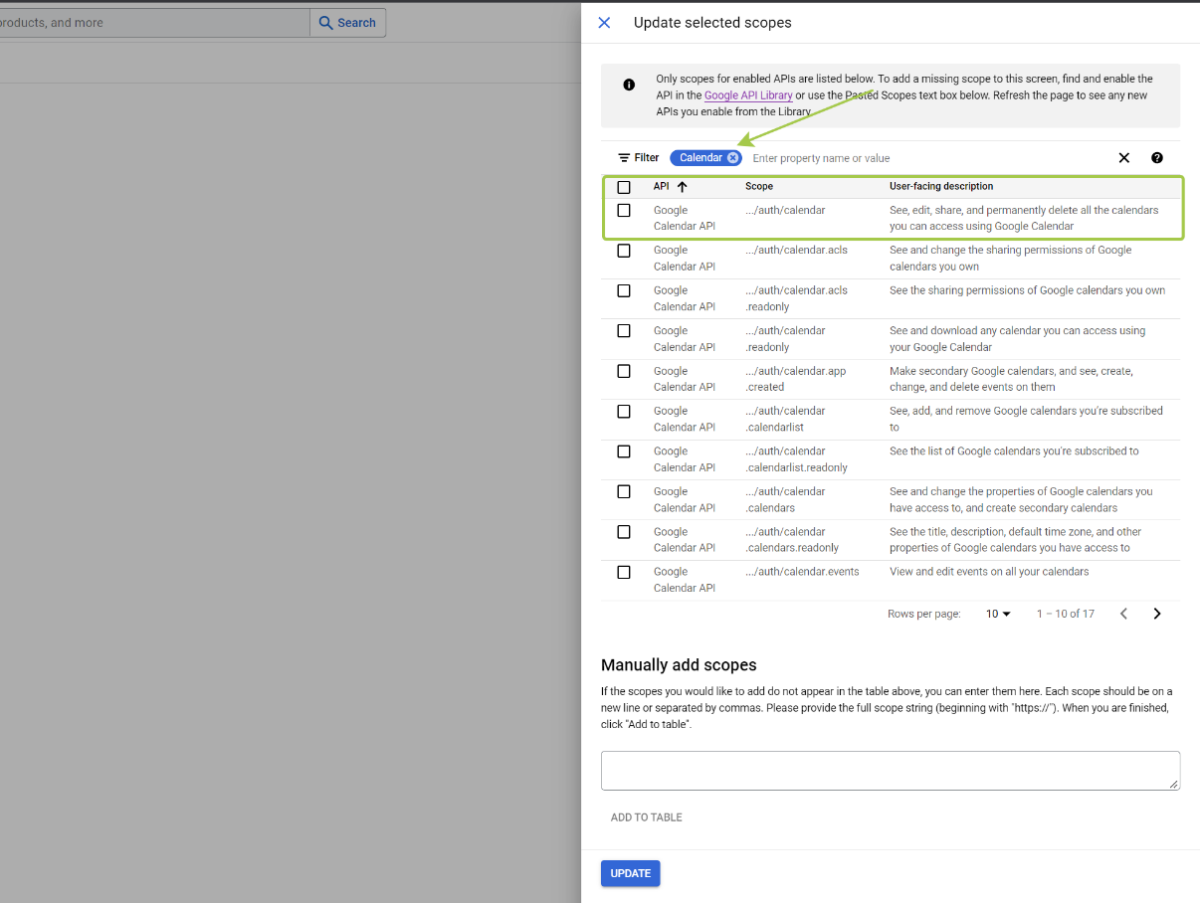
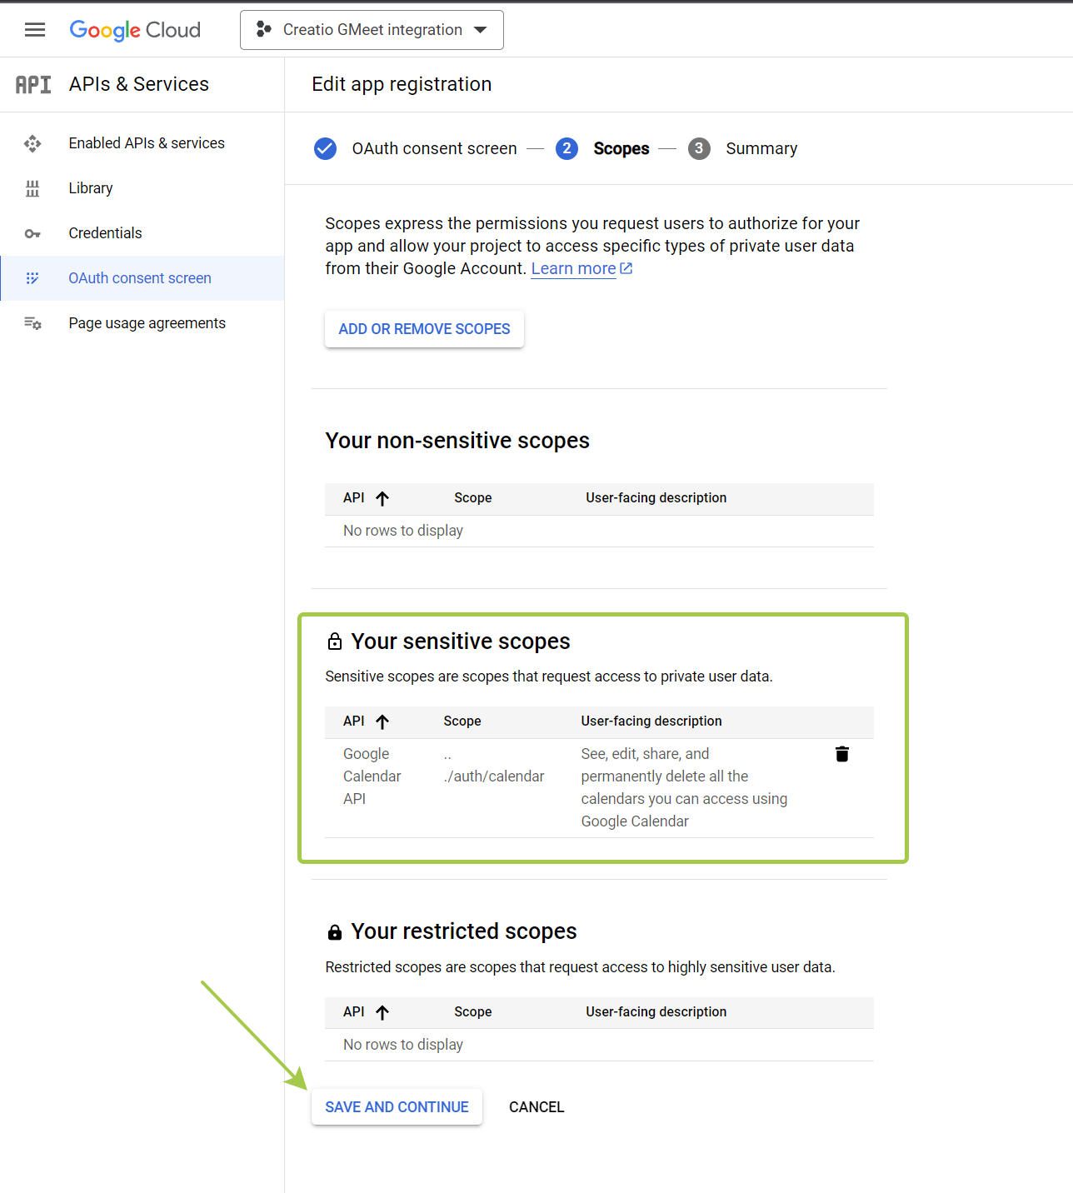
Final result should look like this.
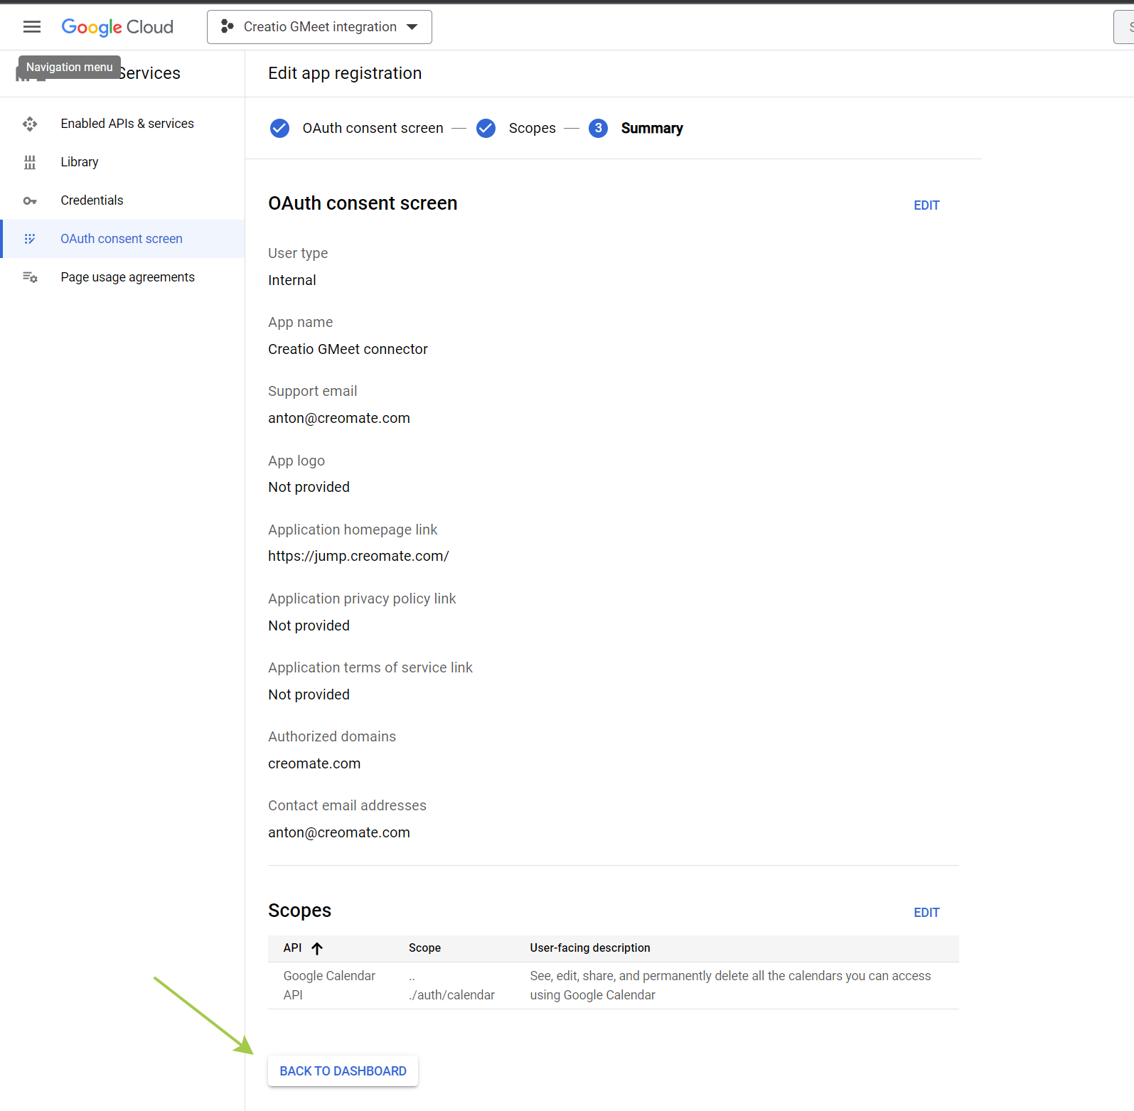

5. Get API key and OAuth Client ID
Open Credentials tab and create API key
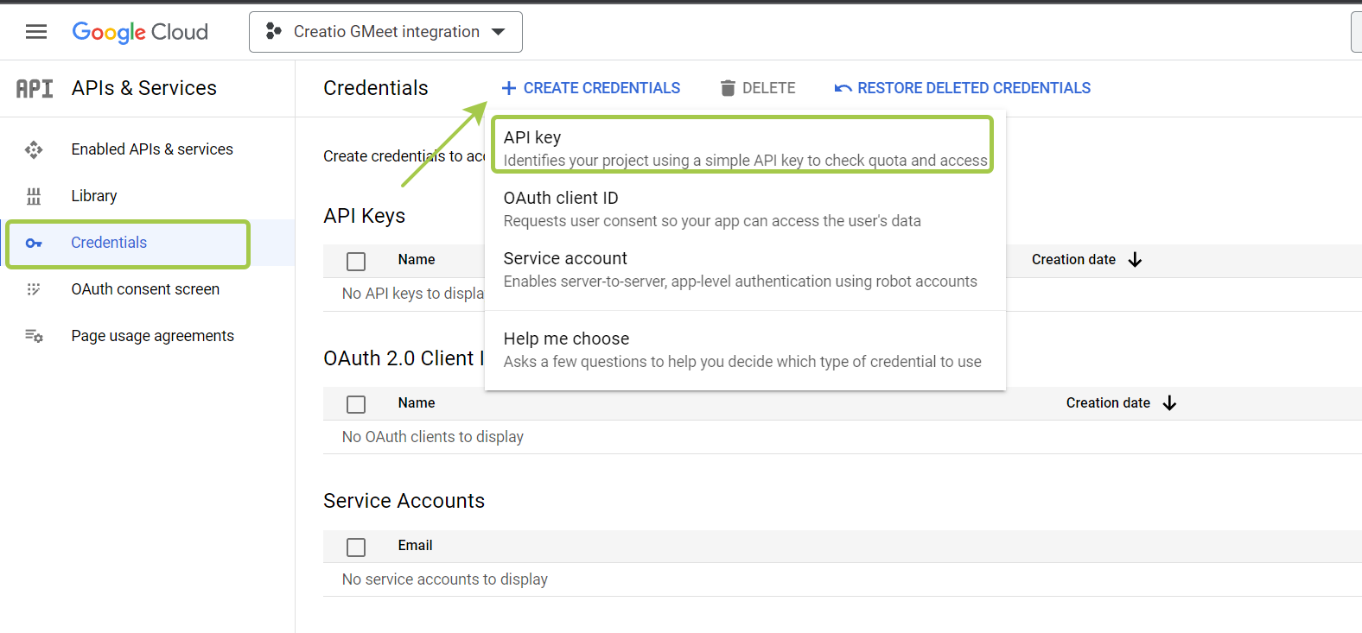
Save it to safe place
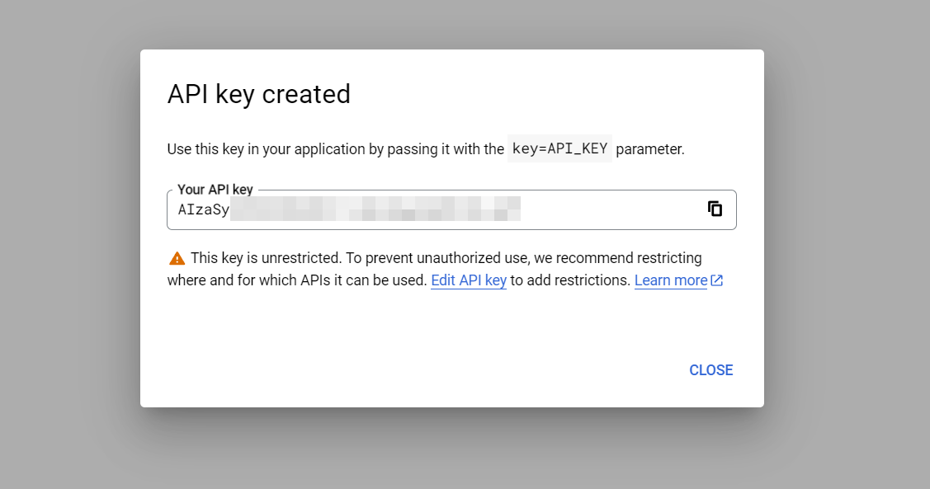
Create OAuth Client ID
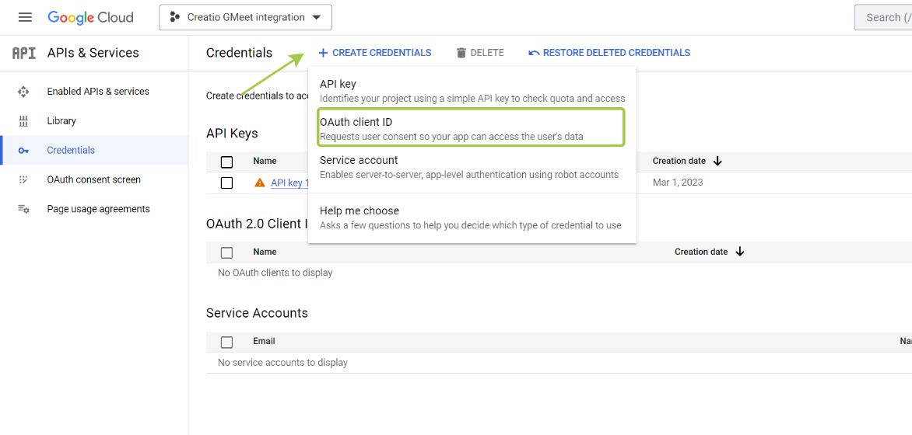
Fill OAuth Client ID parameters:
- Application type should be Web application
- Name should be Creatio
- In Authorized JavaScript origin you should add your Creatio address, like in example
- In Authorized redirect URIs you should add URI from this template – [YOUR_CREATIO_ADDRESS]/0/rest/OmniGoogleAuthService/AuthCallback
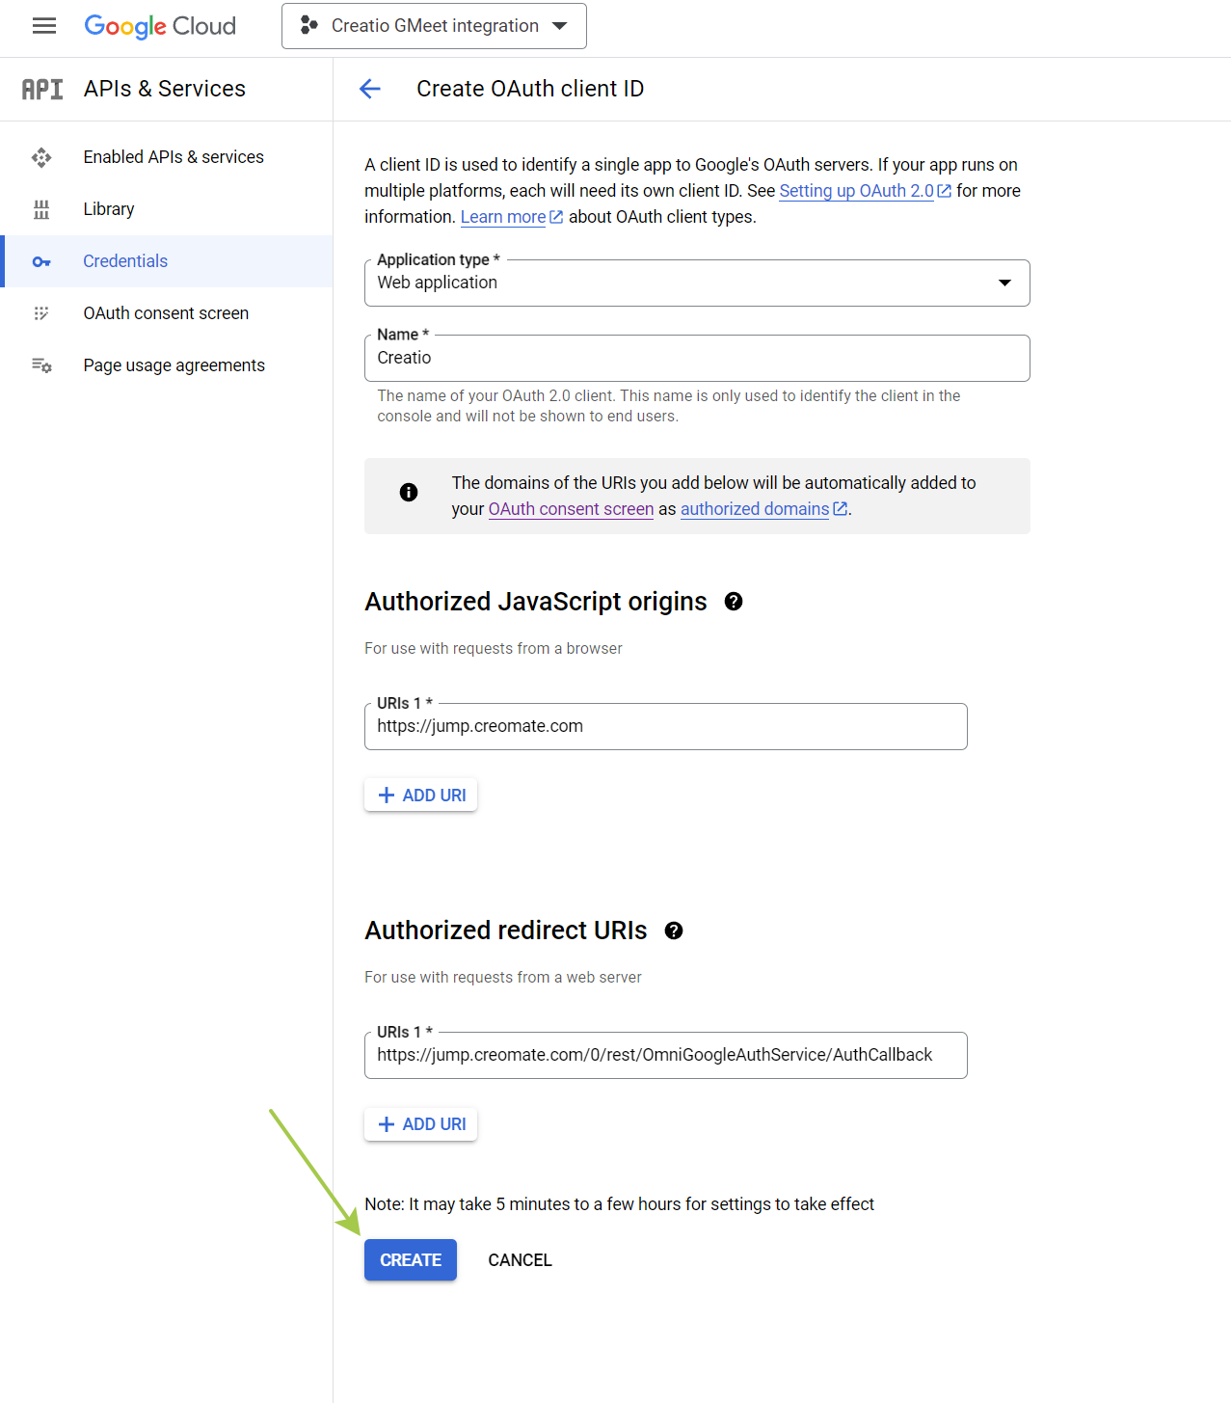

After client creation you will get ClientID 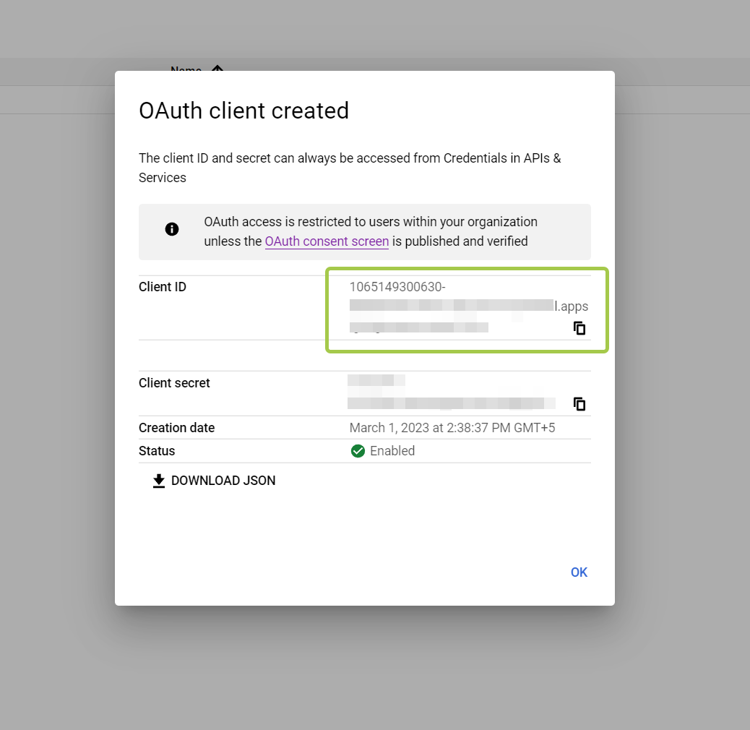
Save it to safe place.
6. Set System settings in Creatio
API key should be saved in System setting Google Meet integration API Key (code OmniGoogleAPIKey).
ClientID should be saved in setting Google Meet integration Client ID (code OmniGoogleClientId)

