Outlook Connector for Creatio
Admin Guide
Table of Contents
Outlook Connector - Admin Guide 2
▪ Requirements 2
▪ Installation 2
▪ Authenticating your Outlook Connector License 3
Support 3

Outlook Connector - Admin Guide

Requirements
The Creatio Connector requires one of the following versions of Outlook:
- Outlook 2013 Windows Desktop
- Outlook 2016 Windows Desktop
- Outlook 2019 Windows Desktop
- Outlook 2021Windows Desktop
- Outlook 365 Windows Desktop
The Creatio Connector is not compatible with Outlook in the browser or on mobile.
Connecting an Email from Outlook to a Record in Creatio requires the Email Account to be configured and receiving emails in both environments (Outlook and Creatio). Emails received in Creatio are handled as Activity records and it is the Activity that manages the connections created using the Connector.

Installation
Download the .zip file containing the Outlook Connector provided by support@kewlconsulting.com once your order has been completed.
Once the file has been downloaded, unarchive the zip file and follow the steps below.
- Run Setup.exe (1)
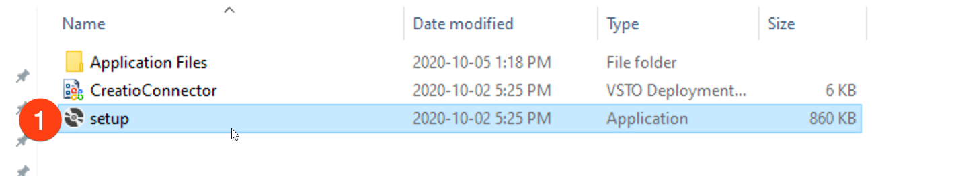
- When prompted regarding the publisher, Kewl Consulting, accept the verification by clicking the Install button (2)
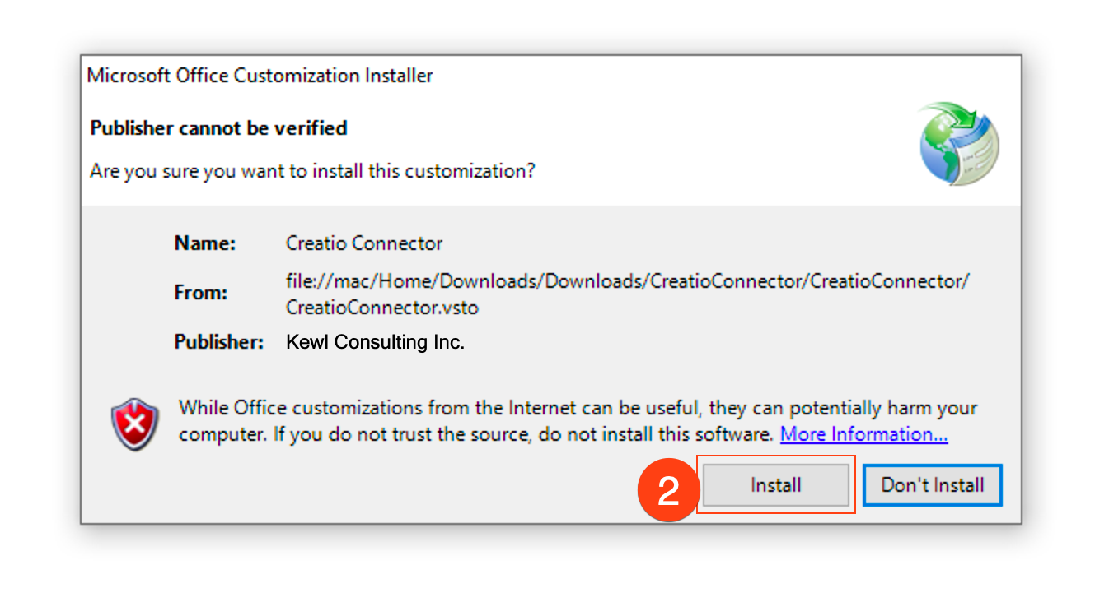
- The installation will take a few moments, once complete the window can be closed (3)
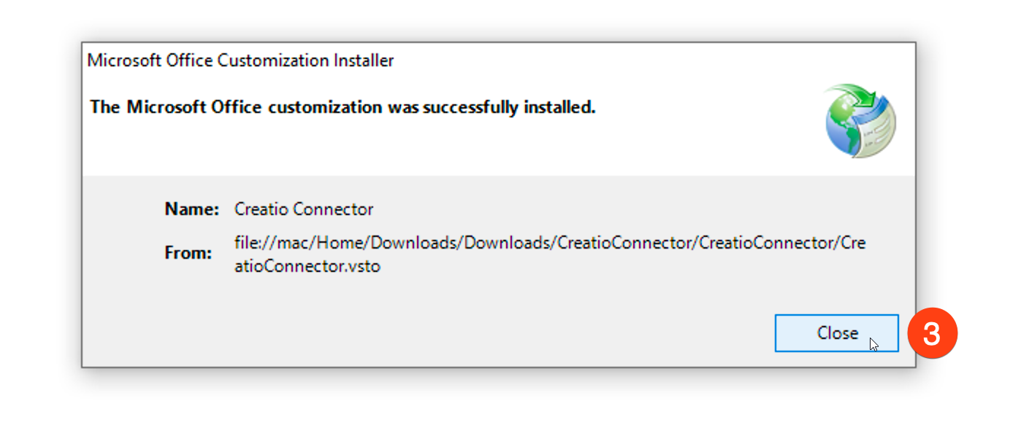

Authenticating your Outlook Connector License
Once the Connector is installed press the Login button. If this is the first time launching the Connector you will be prompted to enter a Kewl Authentication Key. This key is provided by Kewl after purchasing the product. Enter your key and click the Authenticate button to proceed. You only need to enter your key once, and you will need to press the Login button again to sign into your instance.
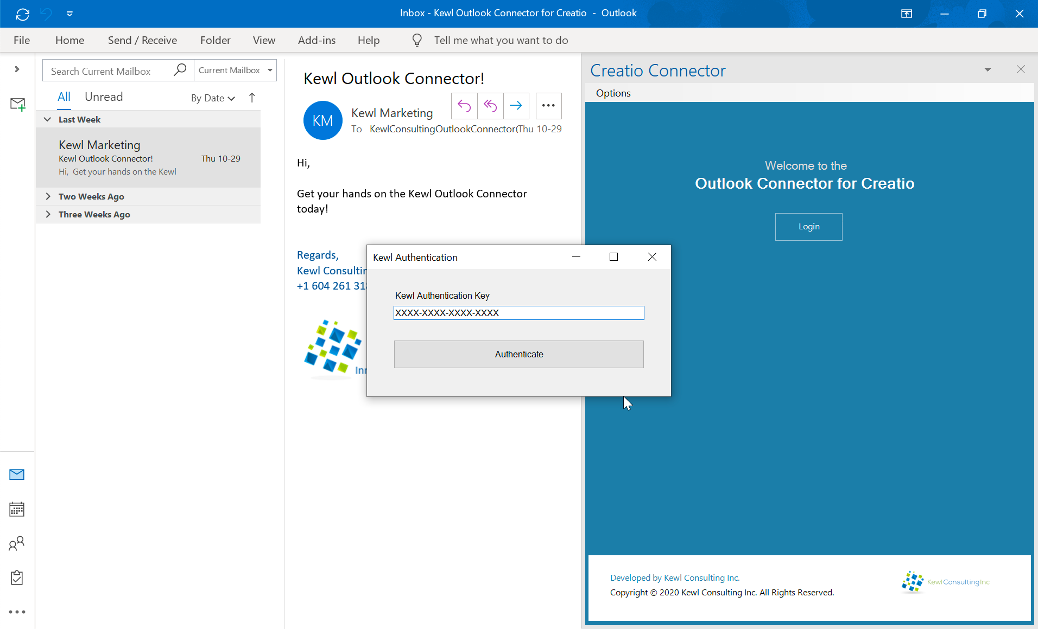

Support
Support is available by email by contacting support@kewlconsulting.com.
Email support is available between the hours of 8:00 am and 5:00 pm Pacific time, weekdays with an expected 48-hour response during working hours.

