Outlook Connector for Creatio
User Guide
Table of Contents
Getting Started 2
▪ Signing into the Connector 2
User Interface 3
▪ Navigating Sections 3
▪ Filtering Results 4
Connecting Records 4
Creating Tasks for Records 6
Processing Email from Outlook 8
Opening the Selected Record in Creatio 9
Opening the Selected Email in Creatio 10
Creating New Records in Creatio 10
Record Permissions and Security 12
Options 12
▪ Word Wrap 12
▪ Row Height 13
▪ Font Size 13
▪ Refresh Interval 13
▪ Confirmation Prompt 13
Support 13

Getting Started

Signing into the Connector
You will need to login to Creatio to validate your credentials. To initiate this process, click the Login button.
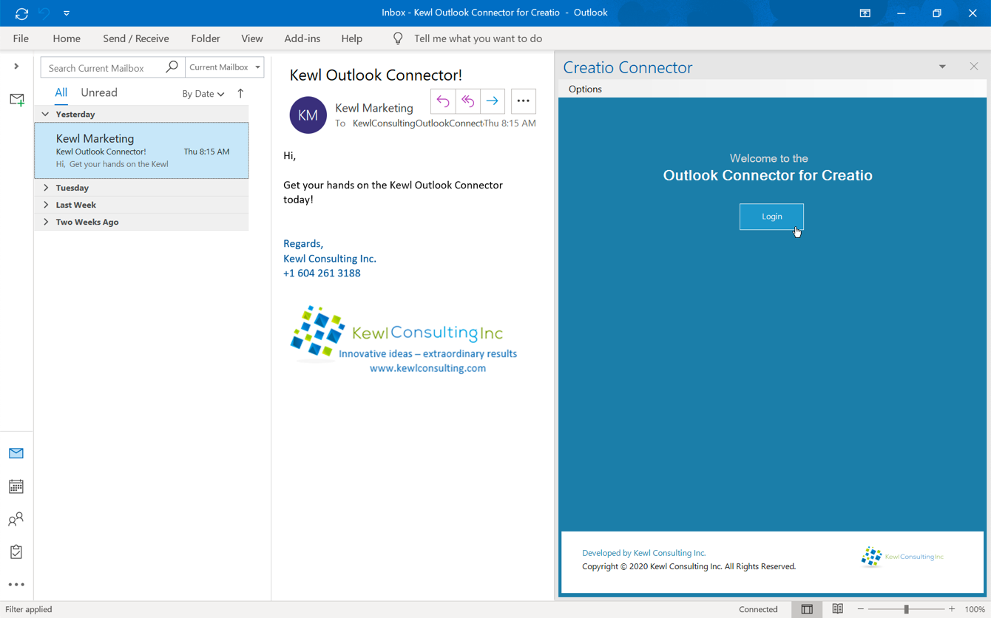
- Enter only your Creatio site identifier as indicated (https://myCreatioSite.creatio.com). In this example you would enter myCreatioSite and not the entire URL.
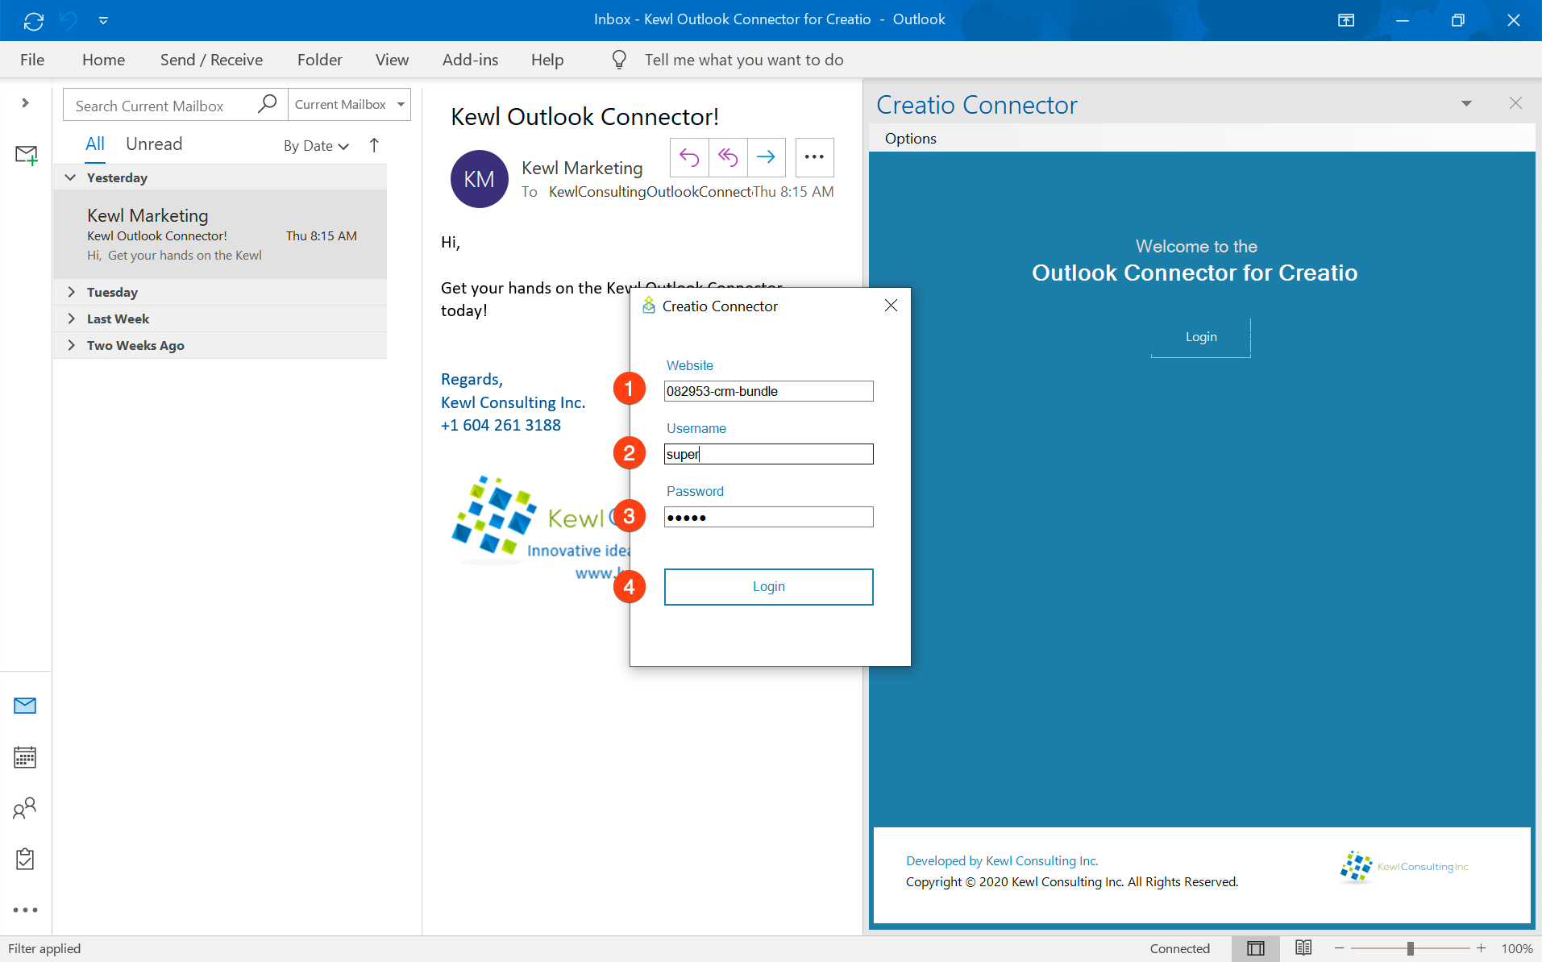
- Add your Creatio Username just as you would when signing into the Creatio application
- Enter your Creatio Password
- Press the Login button
The Connector will display a success message upon successful login, and once the data has been loaded the interface will updated. The Website and Username will be saved automatically and only the Password will be required for future sign in attempts.
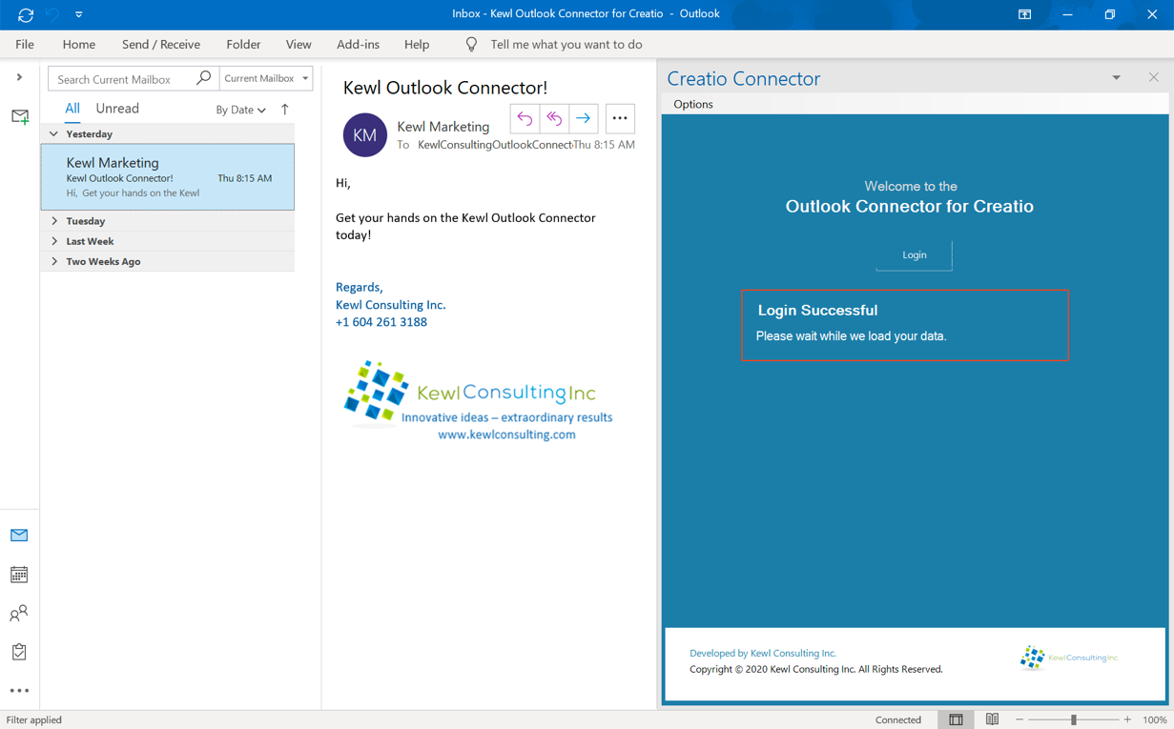

User Interface

Navigating Sections
To view the results of a specific Section, click the respective section button at the top of the panel.
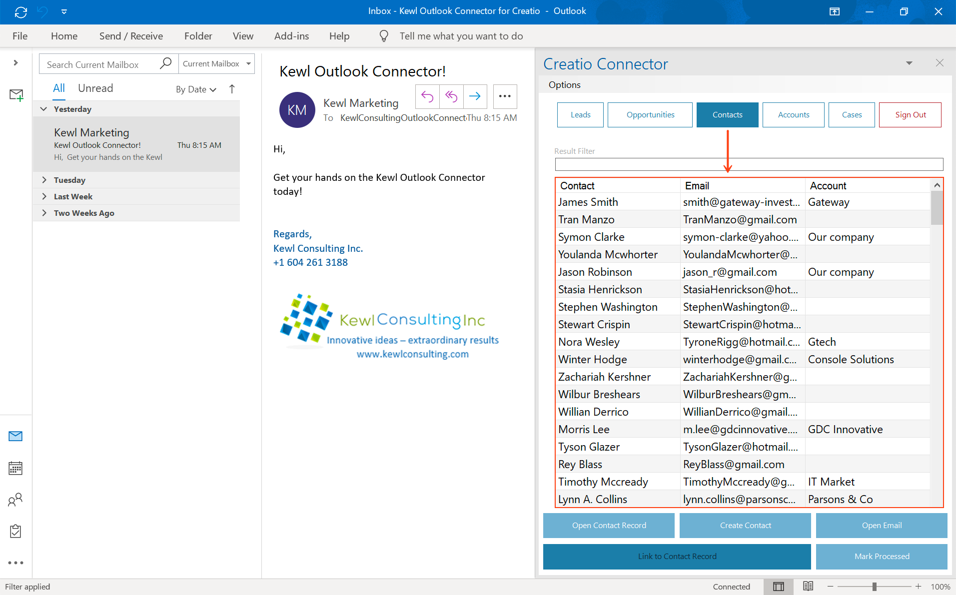
Selecting a section will reload the data in real-time from the Creatio environment. Data for the currently active section can also be refreshed by clicking the section button again.

Filtering Results
The Result filter text box allows for filtering the results in the current view. The filter will actively search as you type, for all columns in the active section.
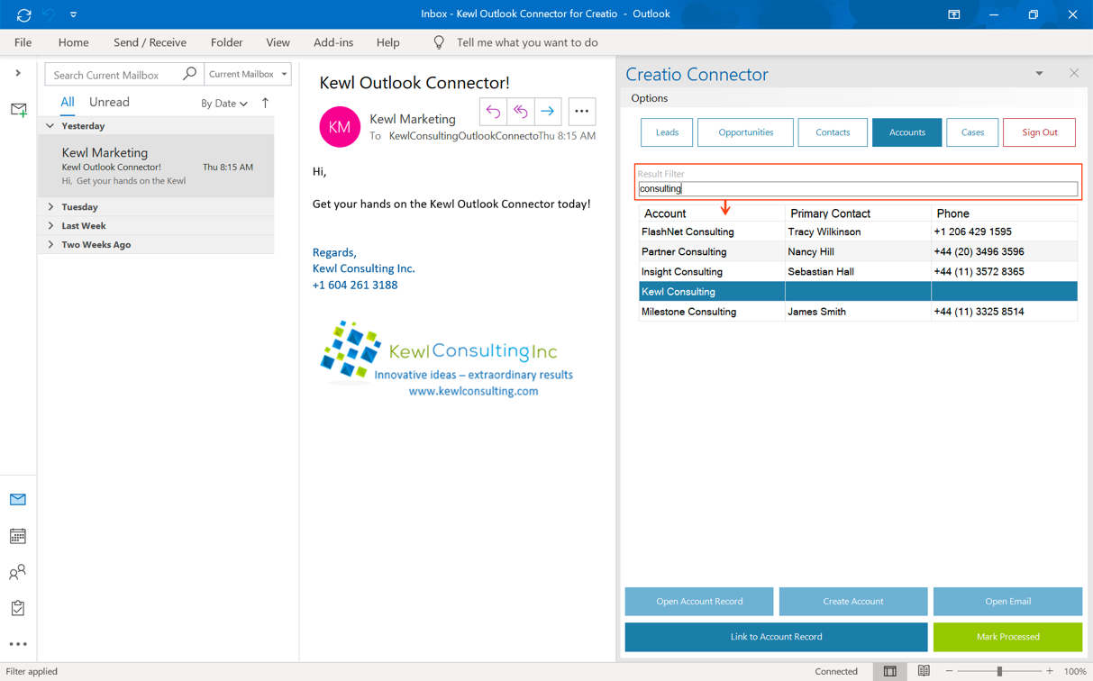

Connecting Records
There are two ways to connect a record to the selected (open) email:
- Double-click the desired record
- Select the record from the list and click the Link to Record button
Both methods begin the connection process by providing a prompt to confirm the connection. This prompt displays the Email Subject and the Record Name.
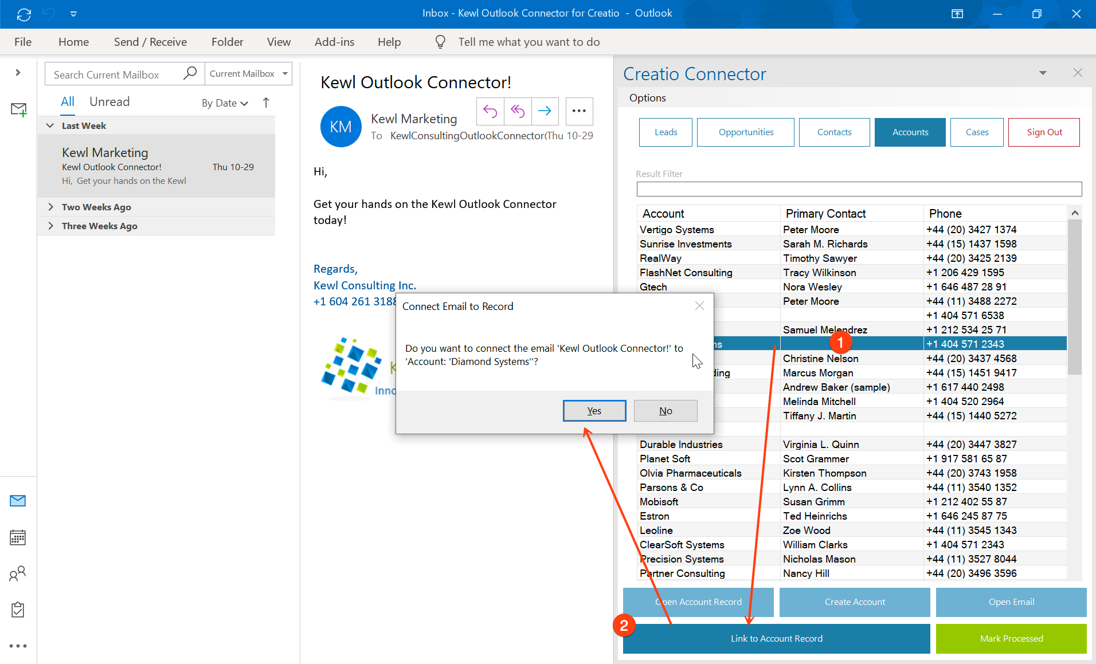
Clicking the Yes button confirms the connection which will then proceed to connect the email to the record. While clicking the No button will simply cancel the connection process.
This prompt can be disabled from the Options menu. Care should be taken when disabling this option as double-clicking a record will automatically run the connection process.
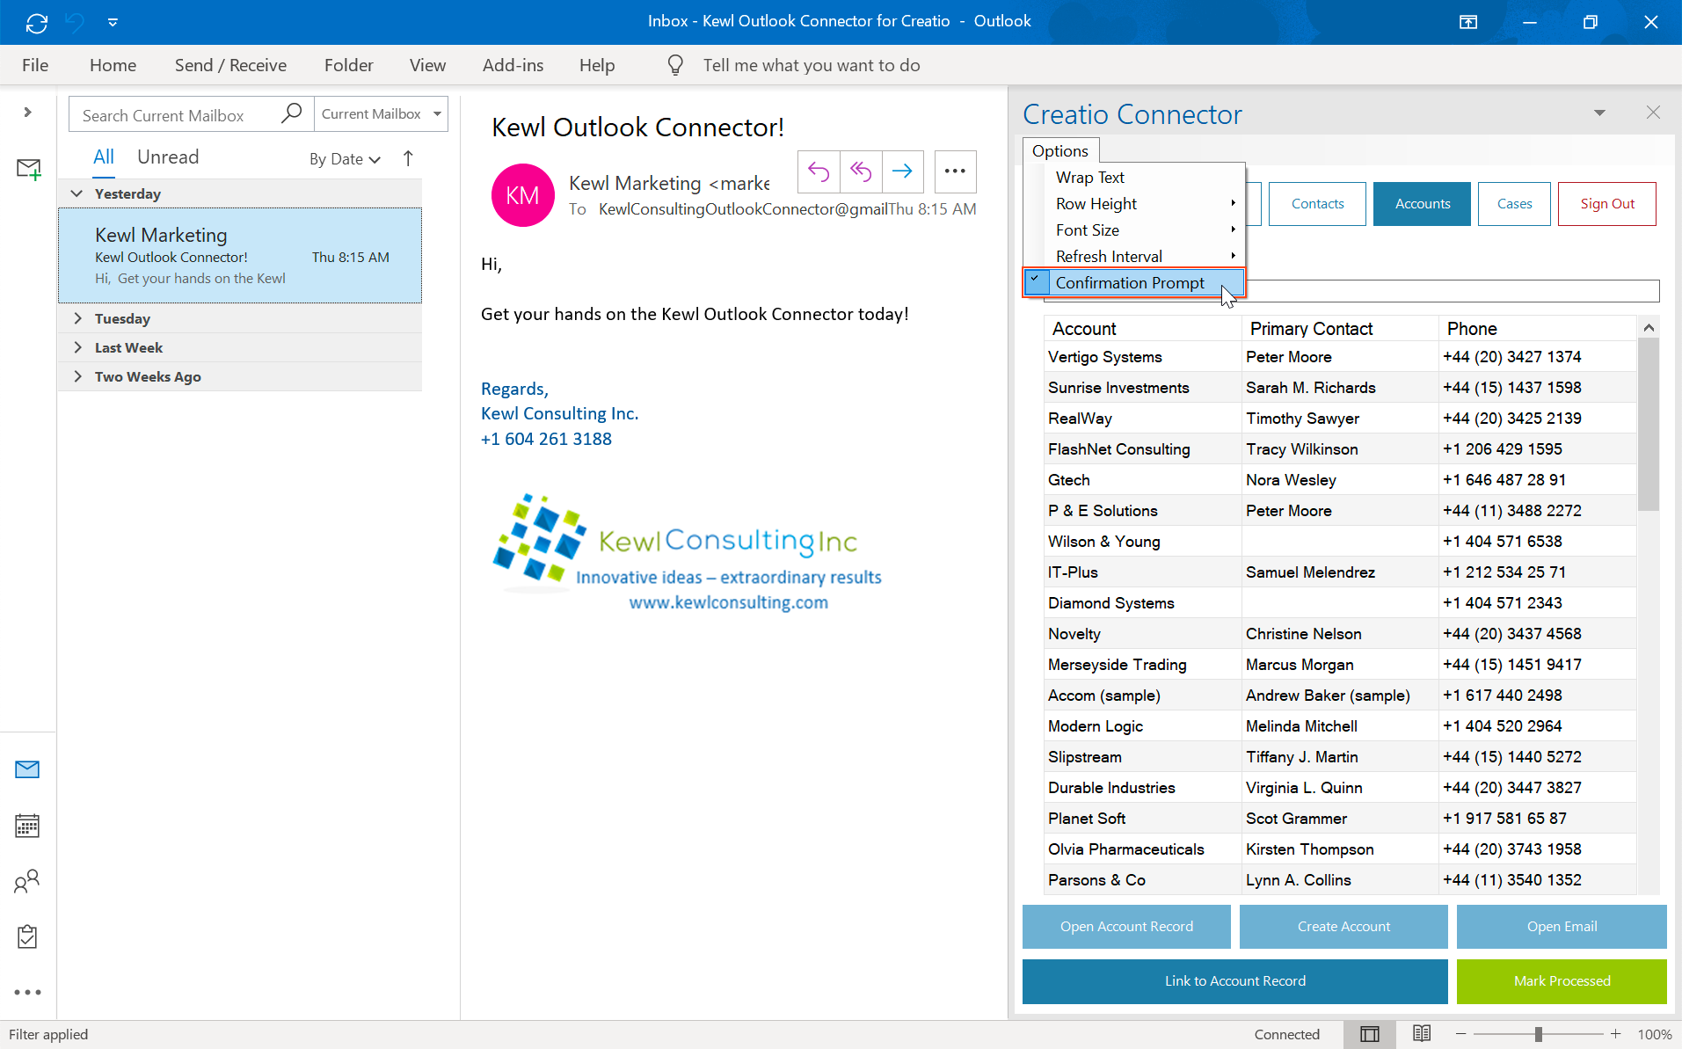

Creating Tasks for Records
Tasks (Creatio Activities) can be quickly created directly from Outlook using the Connector. Tasks are automatically connected to the record for which they are created.
- Right-click the record to bring up the context menu
- Select the Create Task option to open the Create Task pop-up form
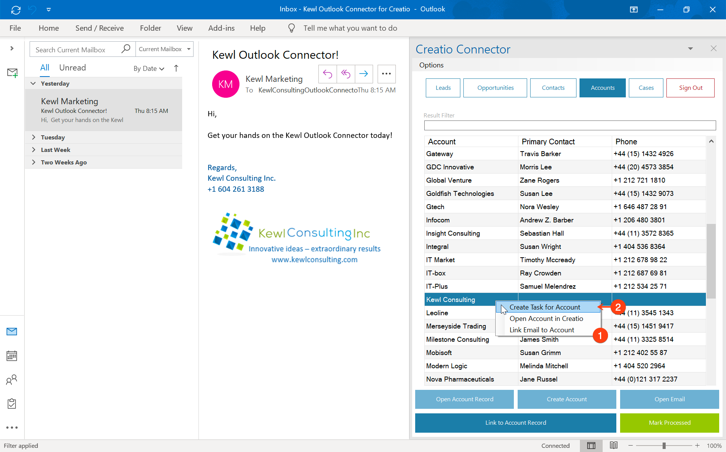
- When the Create Task form opens fill out the necessary fields
  - Subject – this is the title or subject of the task
  - Start Date and Time – the start date and time of the task
  - Due Date and Time – the due date and time of the task
  - Show in Calendar – whether or not the task should display in the calendar view of Creatio
  - Priority – the priority of the task, the values for this lookup are pulled from your Creatio instance
  - Status – the status of the task, the values of this lookup are pulled from your Creatio instance
  - Open Task in Creatio – should the task open in Creatio in a new browser window for additional work
  - Create Task Button – will create the task in Creatio with the configured field values
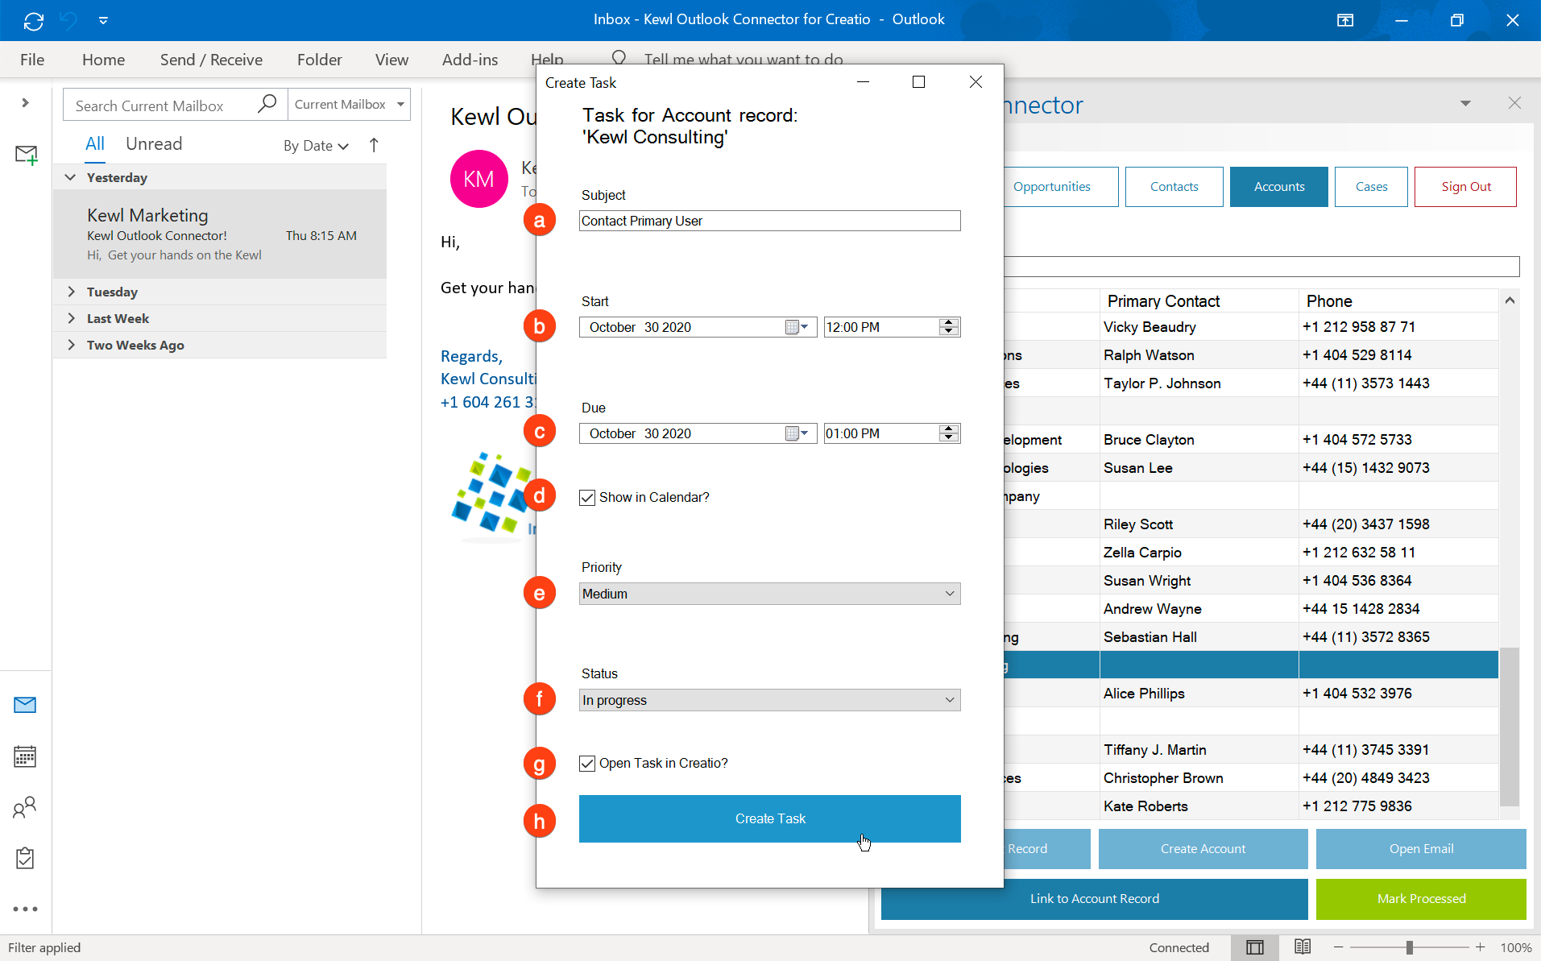
- Since “Open Task in Creatio” was checked on, a browser window will open to the task in Creatio with the respective fields filled in
- Additionally, the Task is connected to the Account for which the task was created
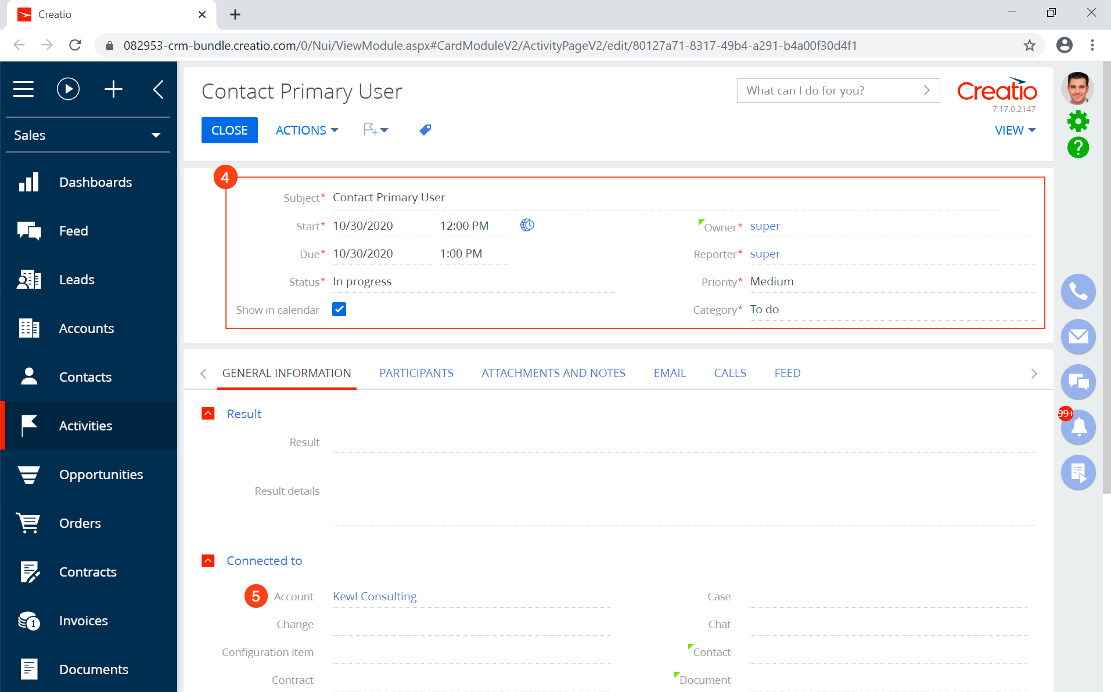

Processing Email from Outlook
Emails can be processed from the Connector in the same way they are processed in Creatio. Select the email (1) and press the Mark Processed button (2). This will mark the email as processed in your Creatio Communication Panel.
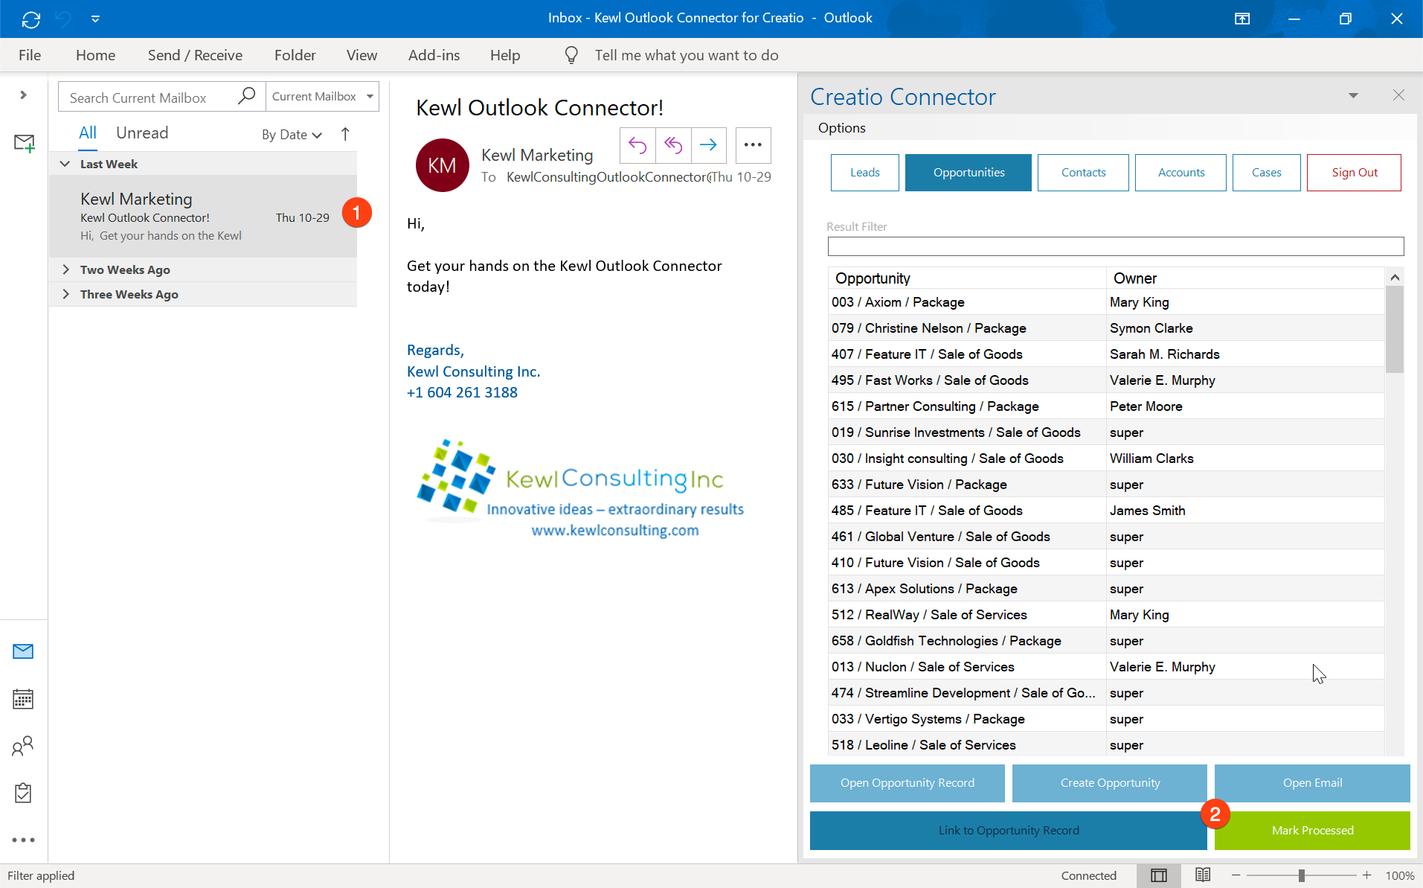

Opening the Selected Record in Creatio
To open the selected record (1) in a Creatio, click the Open “Section ”Record button (2) and a new browser window will open and load the record page in Creatio.
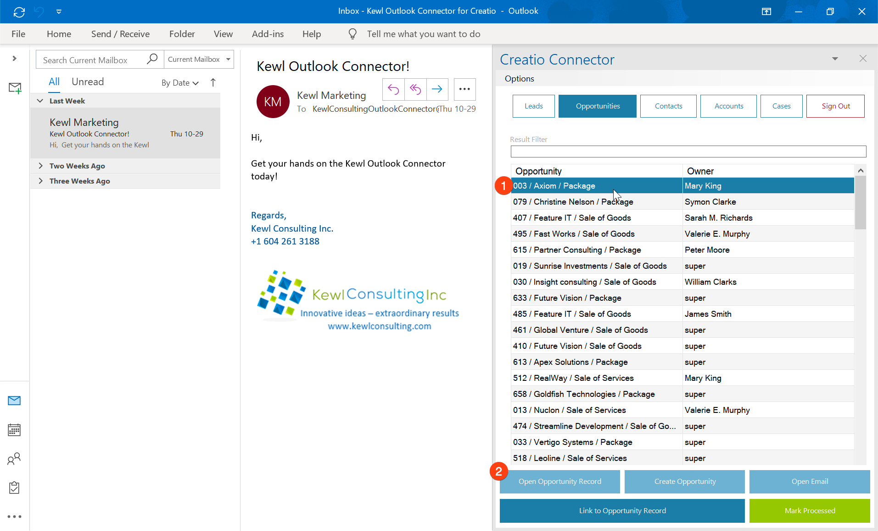
A browser window will open to the selected record in Creatio.
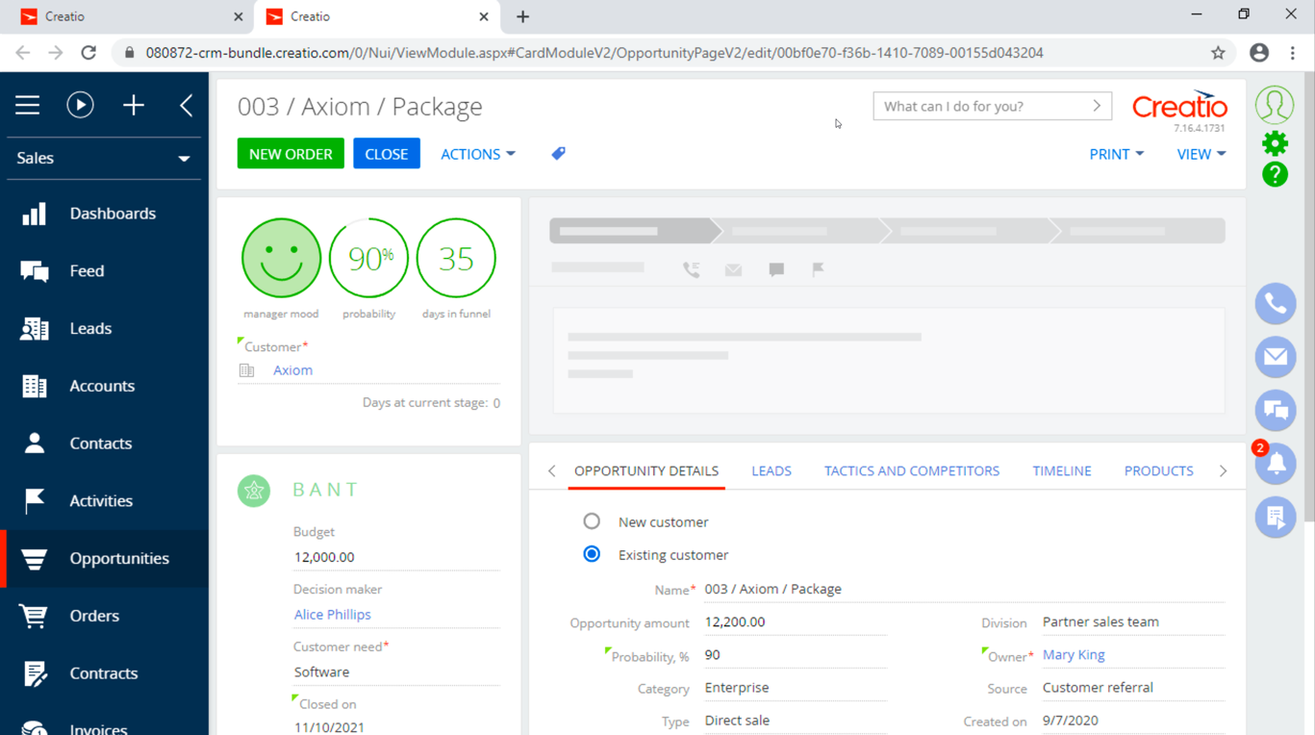

Opening the Selected Email in Creatio
Select the email you would like to open (1) and click the Open Email button (2) to launch a new browser window with the selected email. Note that this function only works for emails that are synced to Creatio with an active email account.
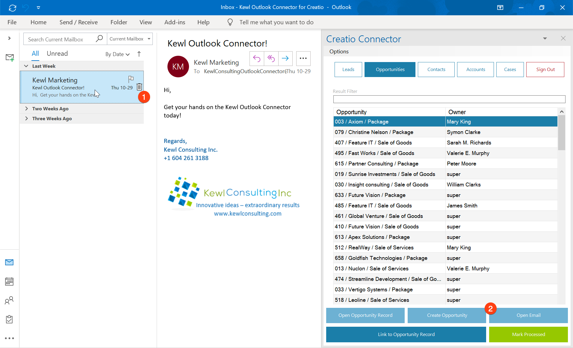
Similar to opening a record, this will open the email activity record in Creatio.

Creating New Records in Creatio
With Kewl’s Outlook Connector Sales & Service PLUS you can also create Creatio records directly from within Outlook. For this example, let’s create a new Lead.
- Click the Lead Button
- Press the Create Lead Button
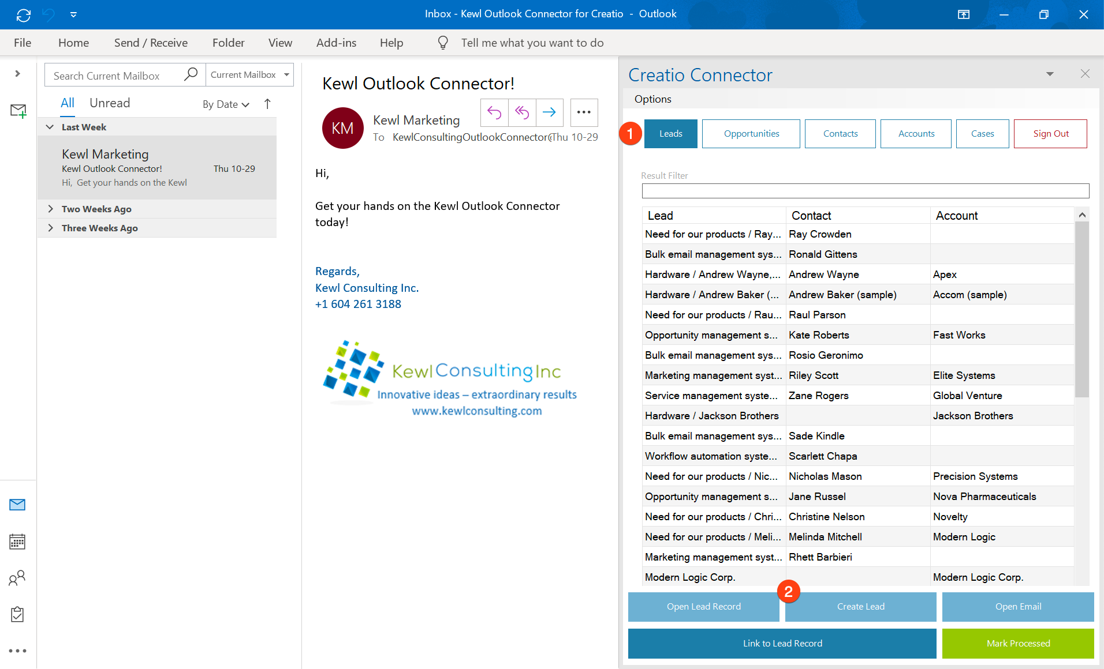
- Fill in the Fields
- Click Create Lead
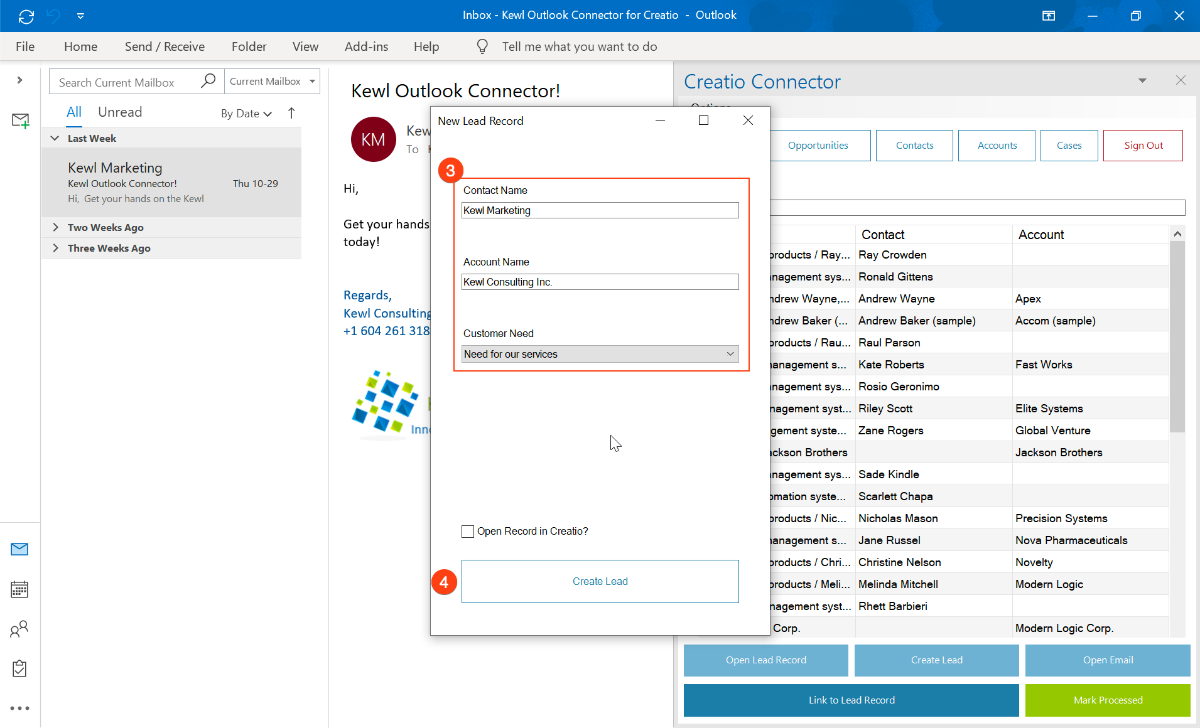
Optionally you can select the “Open Record in Creatio” checkbox to open the record once it has been created.

Record Permissions and Security
Access to system records is not managed by the add-on but through Creatio’s Permissions. The same permissions that apply within the Creatio application will apply within the Connector. Therefore, if a user does not have access to certain records in Creatio they will not have access in the Connector.

Options
There are some available options to change how data is displayed.

Word Wrap
This setting will enable or disable wrapping of the text within a cell. Enabling this might be useful to see all the information in a cell without having to resize the columns or hover over the cell.
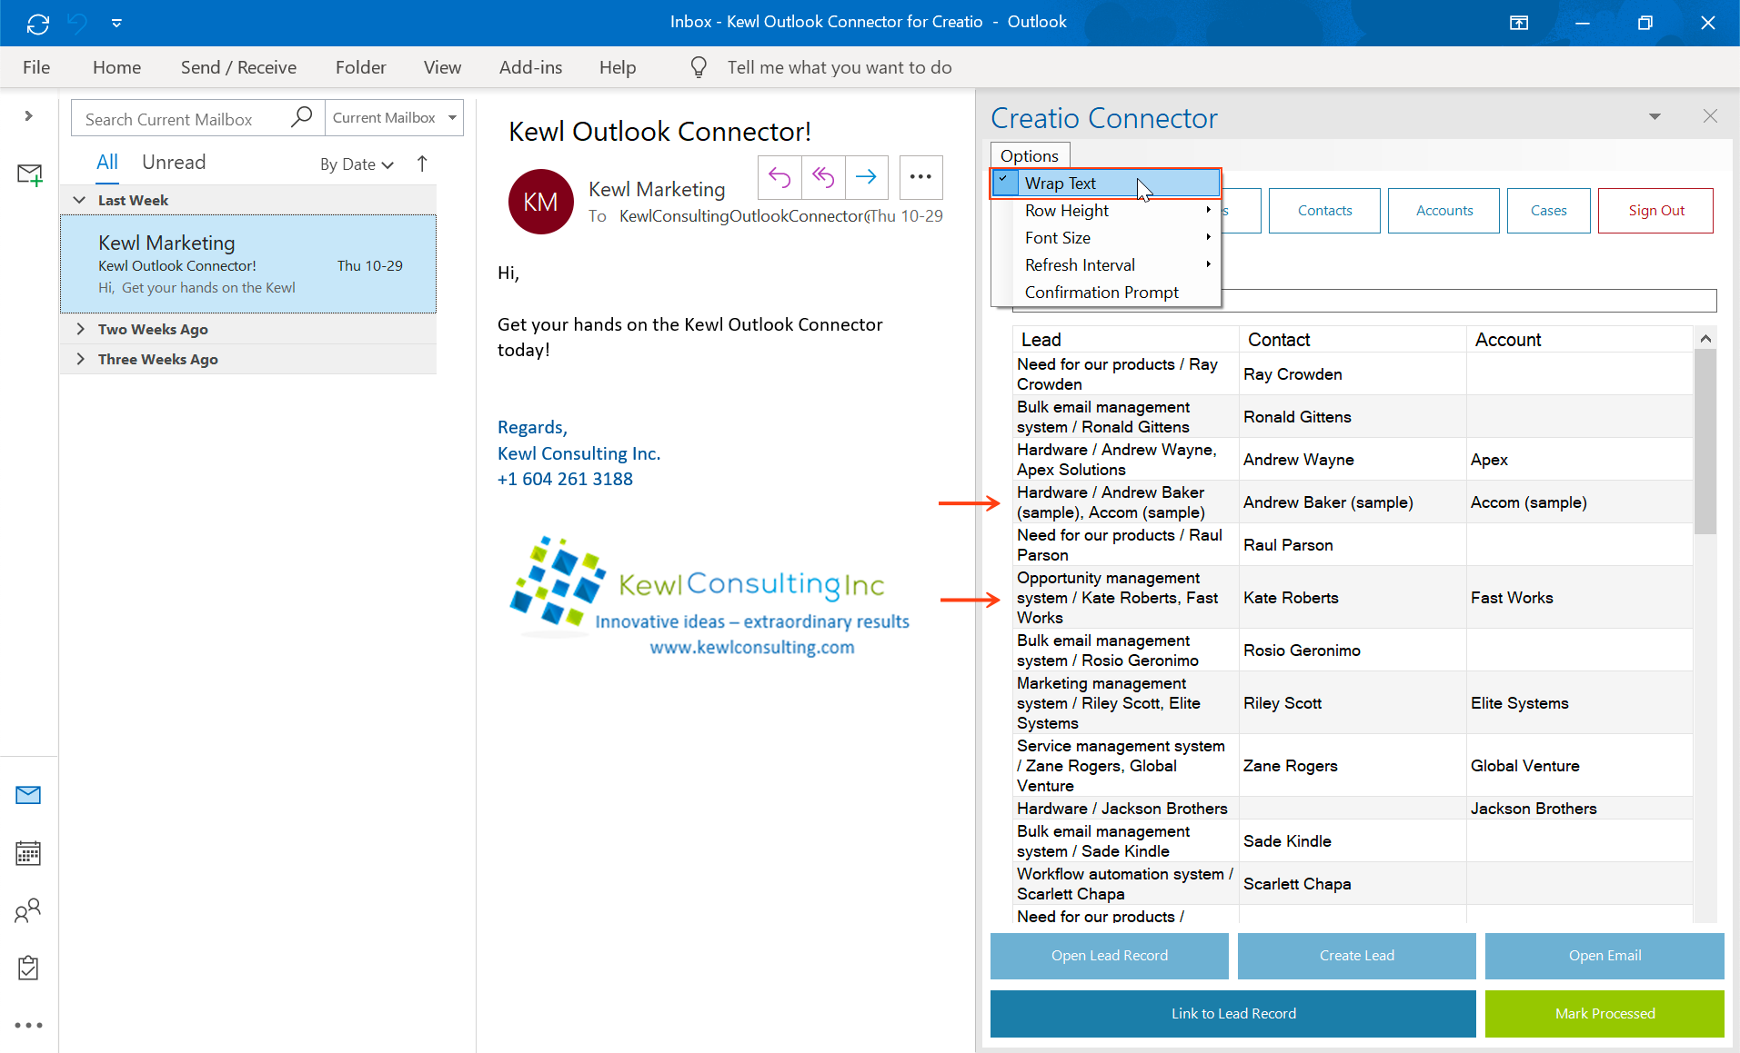

Row Height
This setting allows the height for each row to be set. Options for Small, Normal, and Large row heights are available.

Font Size
For readability there are two font-size settings available. Normal is a 9pt font-size and Large is an 11pt font-size.

Refresh Interval
This setting allows you to set how frequently the Sections should reload data when they are accessed. Setting this to auto will reload the data for the section whenever the section button is clicked.

Confirmation Prompt
When connecting an email to a record, a prompt can be displayed to confirm the connection.

Support
Support is available by email by contacting support@kewlconsulting.com.
Email support is available between the hours of 8:00 am and 5:00 pm Pacific time, weekdays with an expected 48-hour response during working hours.

