Conversation scripts
module setup instructions

Table of contents
Table of contents 2
Preparing for the setup 3
Setting up conversation scripts 4
Setting up Activity to conversation scripts 7
Setting up Queue to conversation scripts 8

Preparing for the setup
Make sure that you append Conversation scripts section to Workplace of user who is responsible for manage Conversation scripts
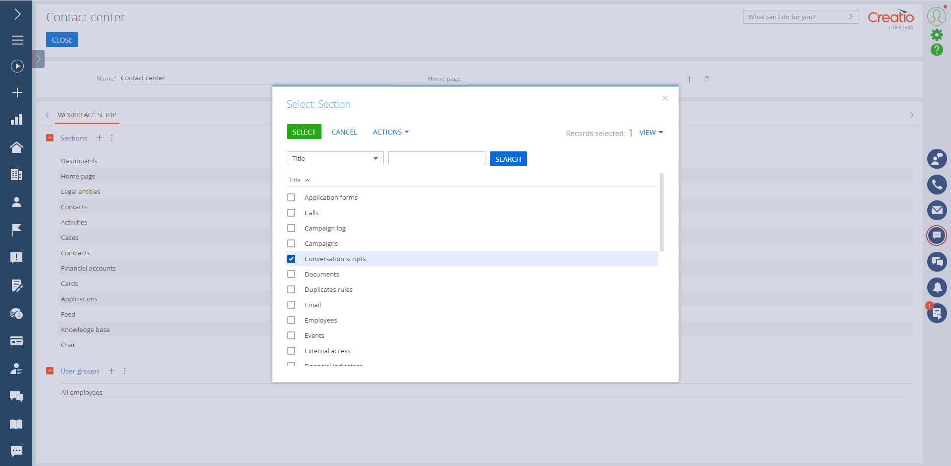

Setting up conversation scripts
In order to add the conversation script, the following sequence of actions is required:
- Go to the Conversation scripts section.
- Click the “New” button.
- Fill in necessary information on the conversation script:

Field name | Description | Example
Name | It is necessary to specify the name of the CS | Financing Lead Script
Entity | It is necessary to specify the Entity, based on the records of which shall be formed CS | Lead
Code | It is necessary to specify the Code of the CS. | 01

- Fill in necessary information on Questions of the conversation script:
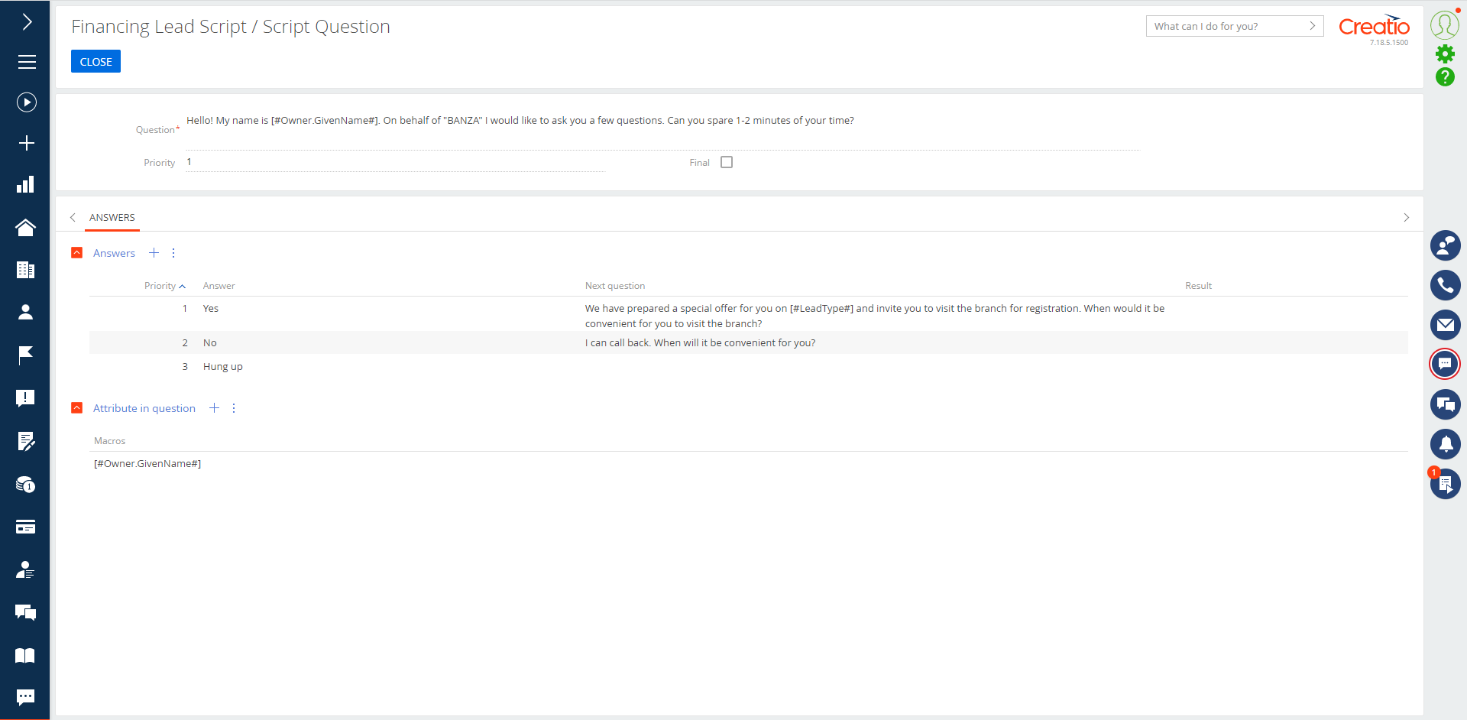
Field name | Description | Example
Question | It is necessary to specify the text of the Question | Hello! My name is [#Owner.GivenName#]. Can you spare 1-2 minutes of your time?
Priority | If it is necessary specify the Priority, of the Question | 1
Final | If it is necessary specify the Final flag, for the Question | False
Attribute in question | Optionally You can add the Attribute in question and use macros in text of Question to build personalized question text | [#Owner.GivenName#]
- Fill in necessary information on Answers of the Question:
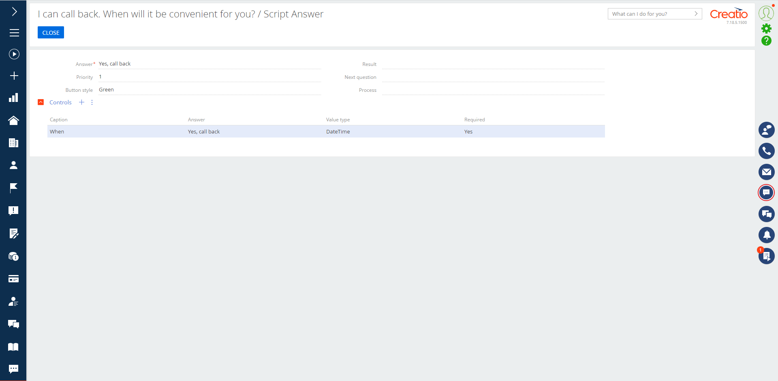
Field name | Description | Example
Answer | It is necessary to specify the text of the Answer | Yes, call back
Priority | If it is necessary specify the Priority, of the Answer | 1
Result | If it is necessary specify the Result, for the Answer | Agree
Next question | If it is necessary specify the Next question from questions list, for the Answer | We have prepared a special offer
Button style | If it is necessary specify the Button style, for the Answer | Green
Process | If it is necessary specify the Process, for the Answer
Controls | Optionally You can add the Controls in Answer to use it to specify some data in this Answer | Caption: When  Value type: Date/Time  Required: True  Priority:1

Setting up Activity to conversation scripts
In order to add the Activity to conversation script, the following sequence of actions is required:
- Go to the Activity section
- Set up “The process of processing activity according to the conversation script” for selected record in Run business process from section and Process parameter where the record is passed is set to “ID of the selected record”
- Click the “New” button
- Choose category Call
- Fill in Conversation script in Activity
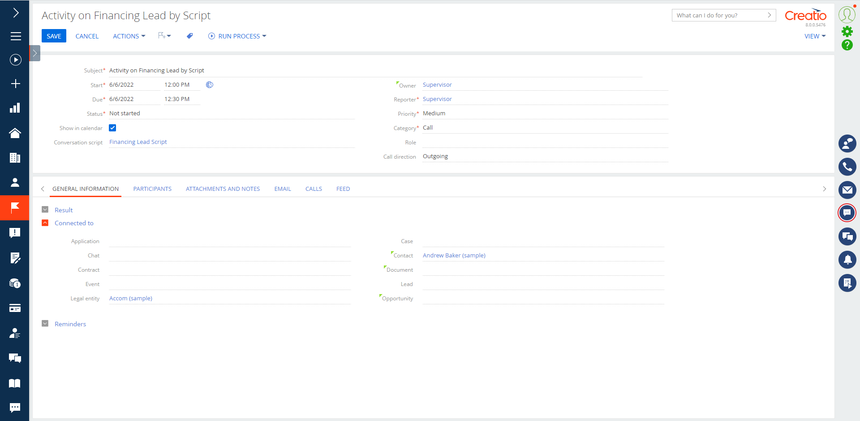
- Run process of processing activity according to the conversation script on created Activity

Setting up Queue to conversation scripts
In order to add conversation script to the Queue, the following sequence of actions is required:
- Go to the Queue section
- Click the “New” button
- Choose Queue type same as Entity in Conversation script
- Fill in Conversation queue parameters as usual
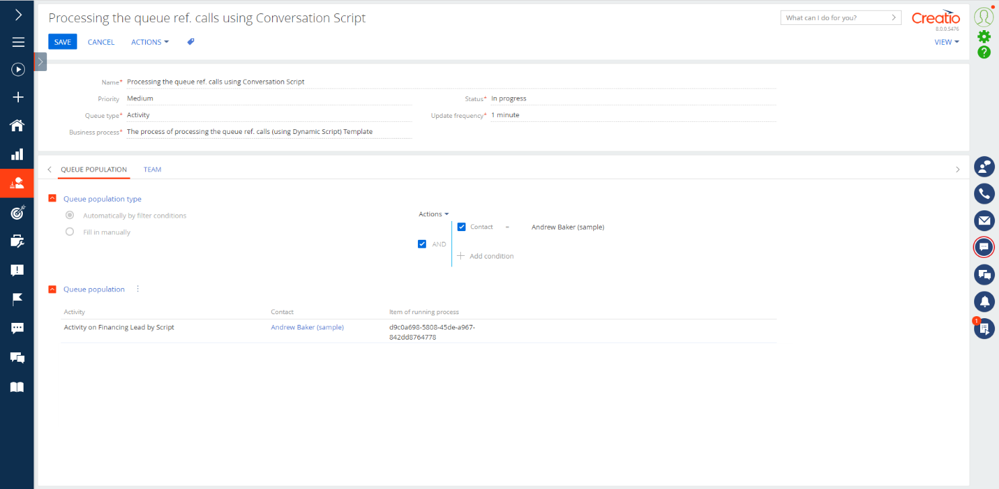
- Use “The process of processing activity according to the conversation script” and fill free to customize process in Creatio Low-code process designer if you need.
- Process Queue elements using your configured scripts!
