Installation and setup guide for “Custom report names for Creatio”

Contents

Contents 2
Introduction 3
Installation 3
Install from file 4
Configuring report’s name 5

Introduction
Application “Custom report names for Creatio” lets you configure names of reports from any section of the system.
Note
Application works only with MS Word reports

Installation
Installation is done in the Creatio’s system. A step-by-step guide:
1. Go to [System Designer];
2. Click the [Installed applications] link;
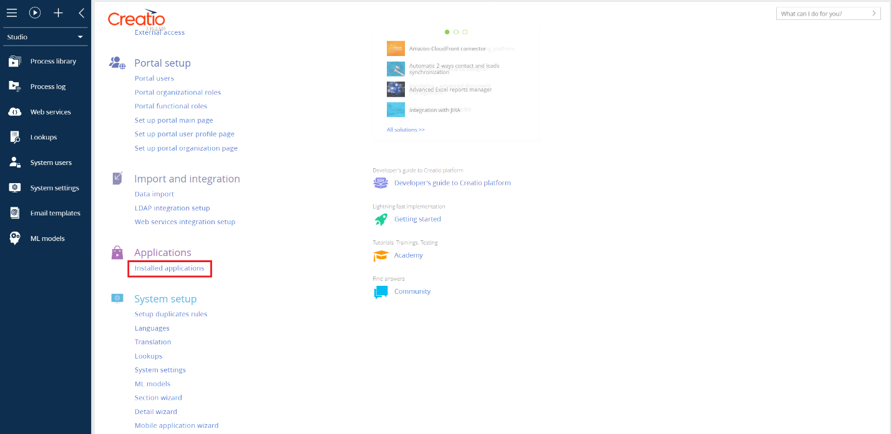
Pic. 1 – System designer
3. Click the [Add application] button;
4. Choose installation option – Choose from Marketplace or Install from file.

Install from file
Pic. 2 – Install from file
- Download Custom report names for Creatio’s packages;
Note
In order to update the app a file needs to be downloaded. If the file is downloaded again a number is added at the end of the file’s name, e.g. ByteCode(2).gz. Before installing the packages, it is recommended to delete any added symbols so that file’s name looks like “ByteCode.gz” in order to update the package and not add a new one.

- Choose the file on the installation page 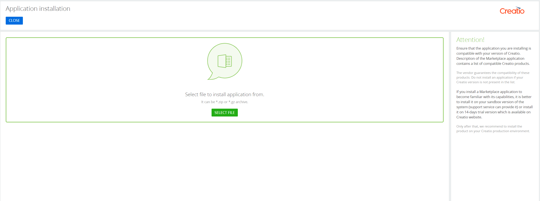
Pic. 3 – Installation page
- Wait until the installation is finished;
- Relog back into the system.

Choose from Marketplace
- Choose an app by name Custom report names for Creatio;
- Click [install];
- Enter your Creatio web-site address into the field and click [Install];
- Wait until the installation is finished.
- Relog back into the system.

Configuring report’s name
To configure a report’s name, you need to:
- Go to [System designer] by pressing a cogwheel icon in the top right corner.
- Click the [Configure report’s names];
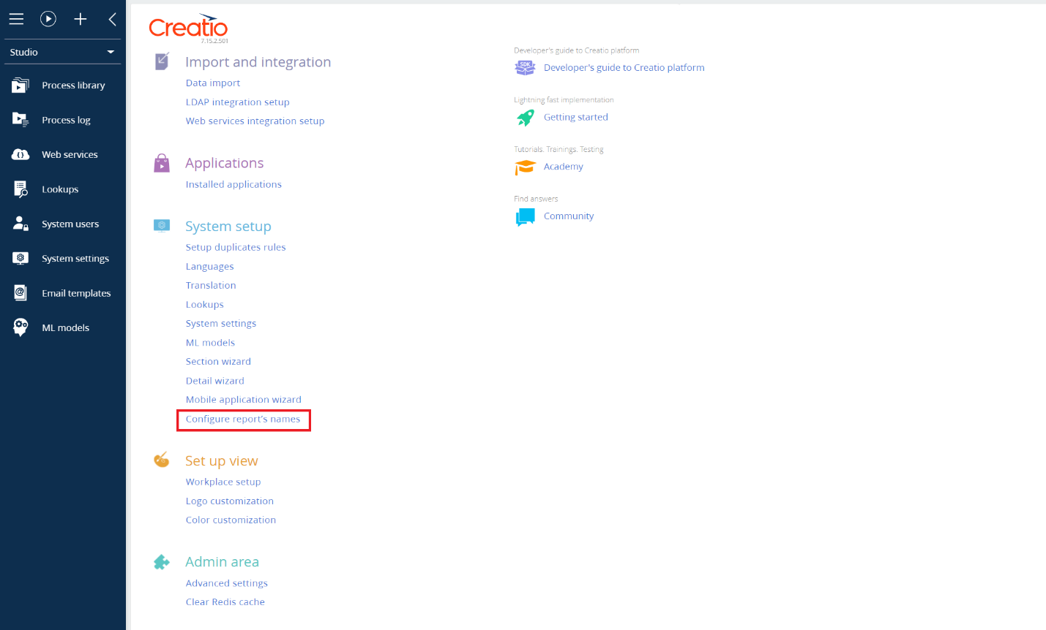
Pic. 4 – System designer

- Click [New];
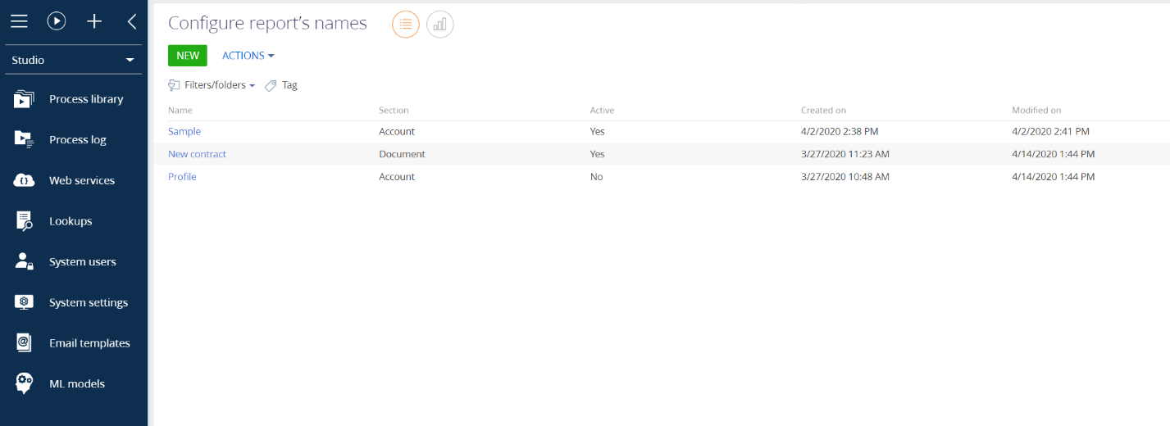
Pic. 5 – Section «Report’s name configuration»
- Fill in all required fields:
  - Field [Report] (column type Lookup) is a required field. A list of reports that are stored in Creatio’s library is opened;
  - Field [Name] (column type String) is a required field. The name of configuration. For example, “Working contract”;
  - [Section] is filled in automatically and is uneditable. It’s dependent on the chosen report. E.g. report «New contract» is stored in [Document] section;
  - Field [Active] (column type Boolean). When activated, report’s fields are uploaded/downloaded with the current record’s configuration

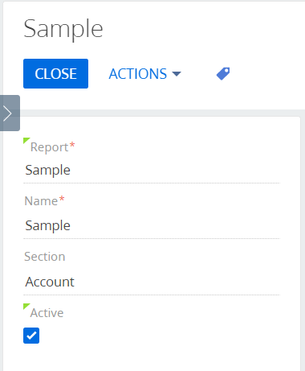
Pic. 7 – Choosing a section to upload/download a report
Description of the fields on the main page:
- Field [Macros’ source {0}] (column type Lookup). Choose a report’s column value that will be placed in a report’s name.
Pic. 8 – Configuring report’s name
- Field [Macros’ source {1}] (column type String). Choose a report’s column value that will be placed in a report’s name. Filled only if 2nd column needs to be displayed.
- Field [Macros’ source {2}] (column type String). Choose a report’s column value that will be placed in a report’s name. Filled only if 3rd column needs to be displayed.
- Field [Macros’ source {3}] (column type String) Choose a report’s column value that will be placed in a report’s name. Filled only if 4th column needs to be displayed.
Note
After choosing a column, the field shows column’s title in database. If lookup field is chosen then macros’ source field is filled with “Lookup field’s title. Displayed value” and а symbol is placed near the field showing that field’s type is a lookup.

- 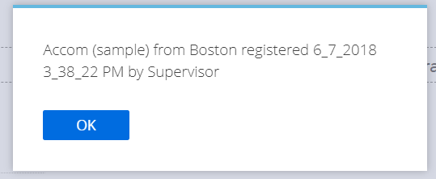Button [Check] is used to preview report’s name (requires to choose a record in a section)

Pic 9 – Report’s name preview
- Field [String’s format] (column type String) is a required field. Choose an order in which the columns are uploaded/downloaded. Here’s an example:
  - {0} – Name (e.g, Accom (sample));
  - from – a word that’s displayed in a report’s name;
  - {1} – City (e.g., Boston).
  - registered - a word that’s displayed in a report’s name;
  - {2} – CreatedOn (e.g., 6.7.2018 3:38:22 PM);
  - by – a word that’s displayed in a report’s name;
  - {3} – Owner (e.g., Supervisor).
The result of upload/download will look like this:

Pic. 10 – Report’s name configuration result

