Service AI Suite installation guide

1. Install package via Application Hub
2. Get the API key from <https://platform.openai.com/>
   1. Sign in your OpenAI account or create new one https://platform.openai.com/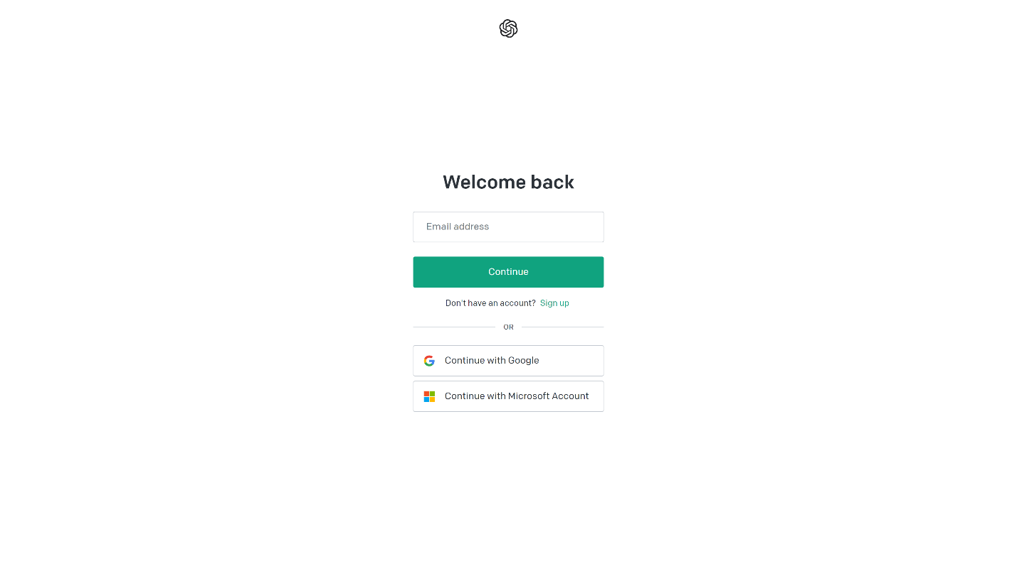
   2. In OpenAI platform main page, open the API Keys page (<https://platform.openai.com/>)

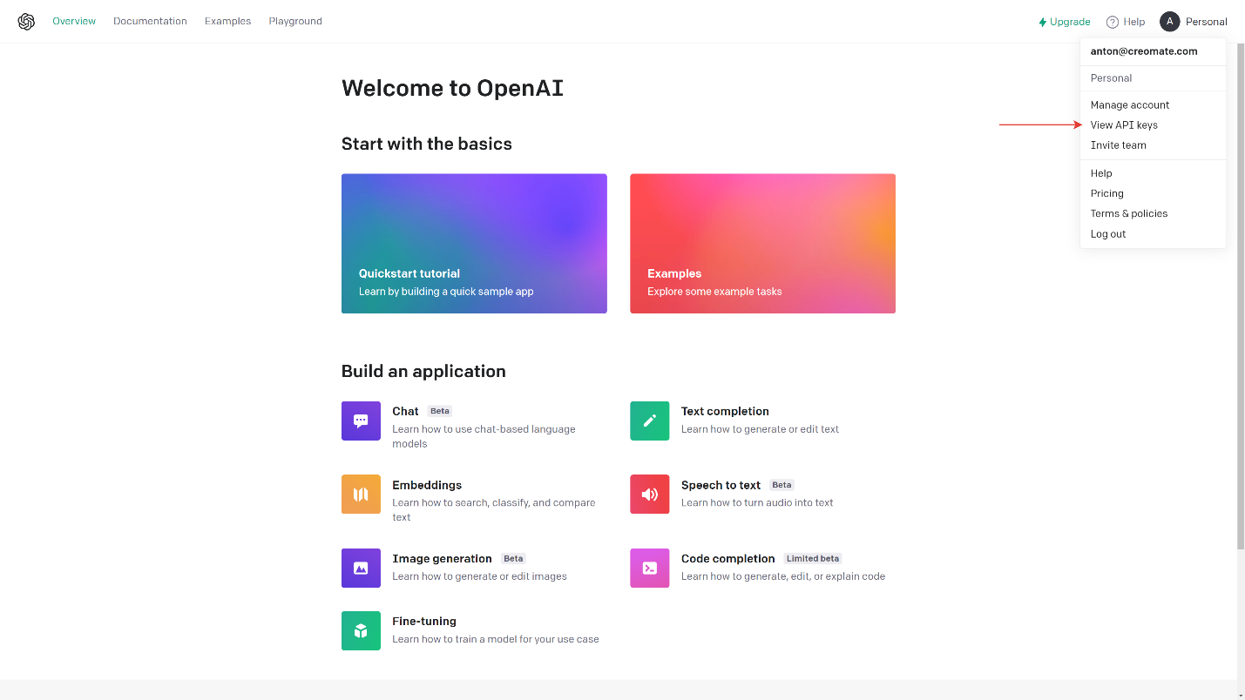

* 1. Create a new key and save it to a safe place.

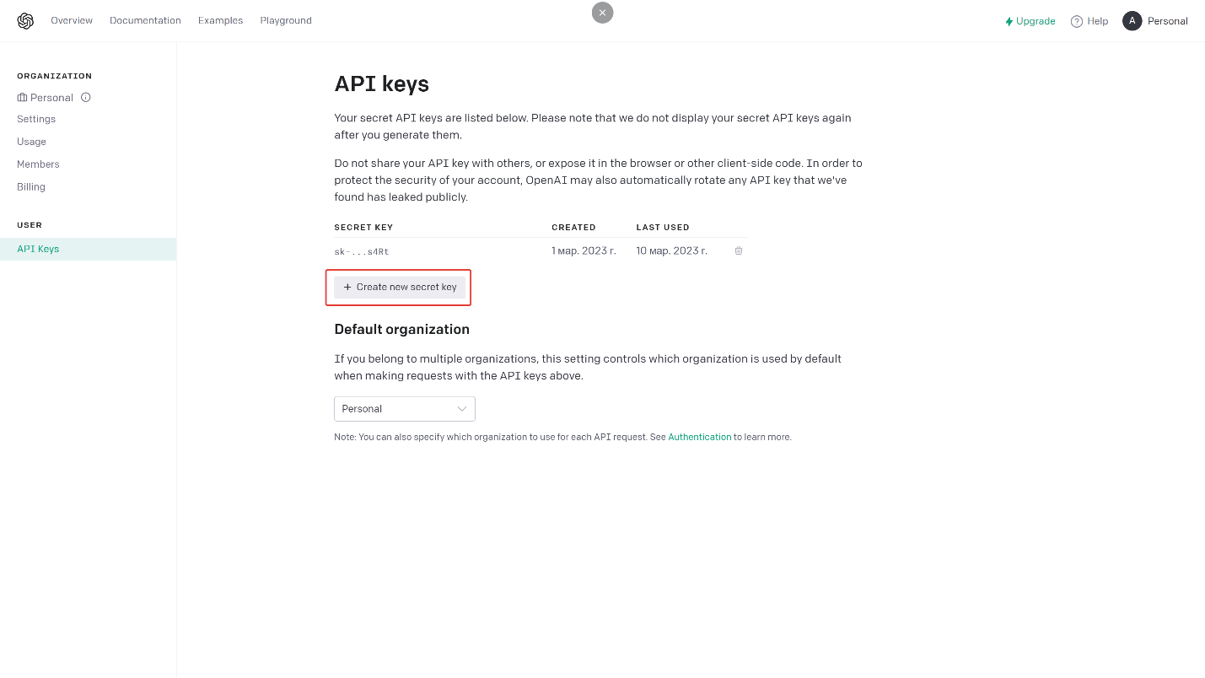

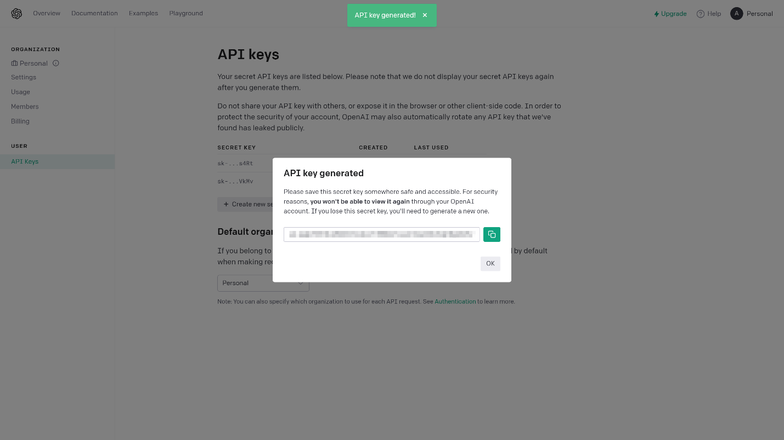

1. Save API key in system settings

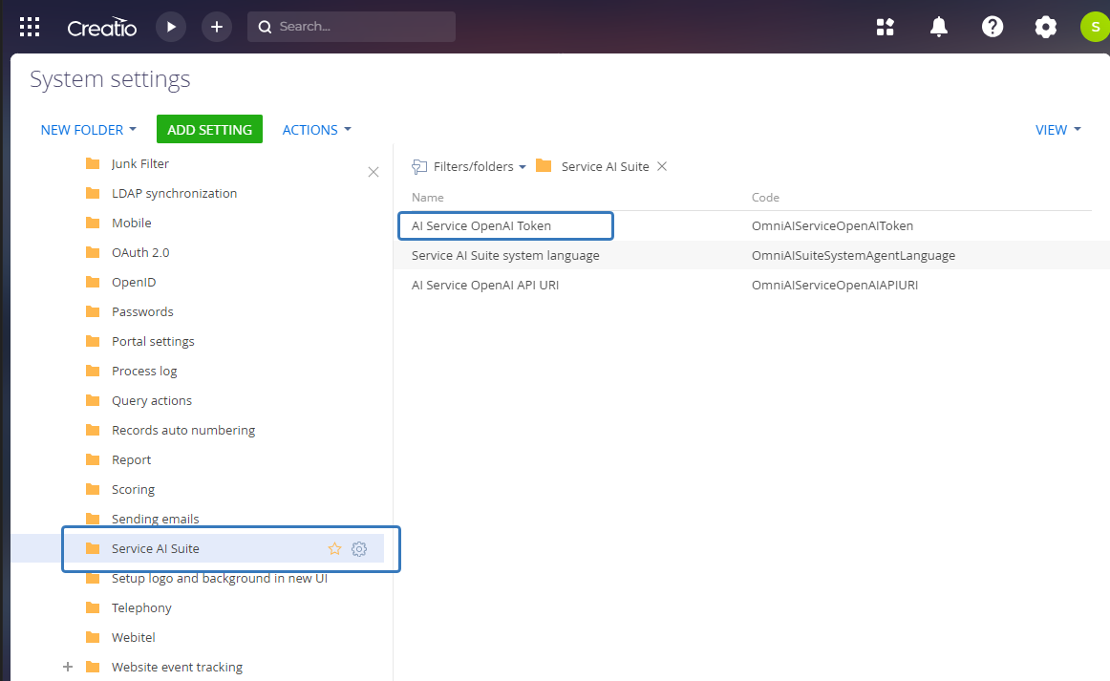

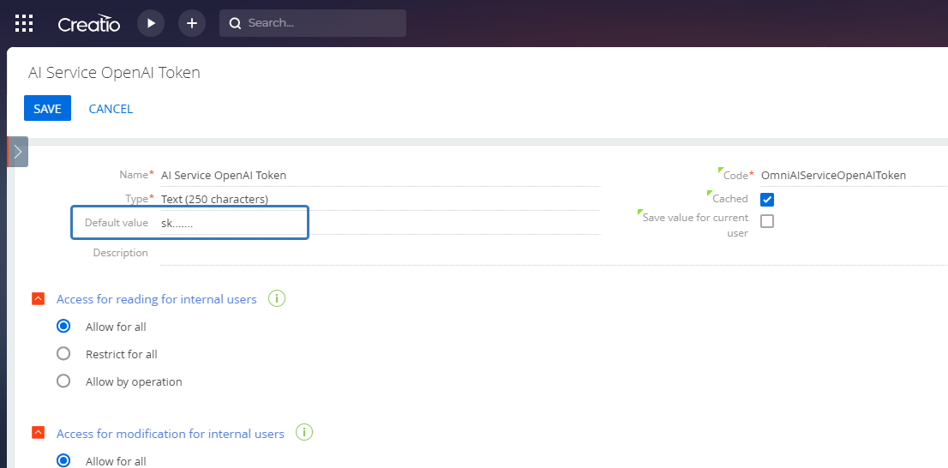

1. Set the system native language

This language will be used as a user’s language for all ChatGPT requests.

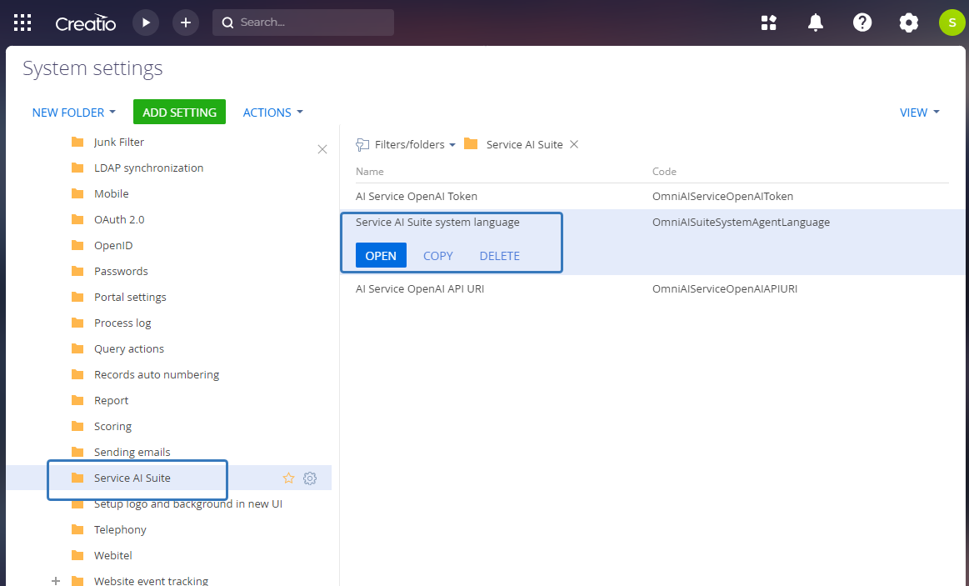

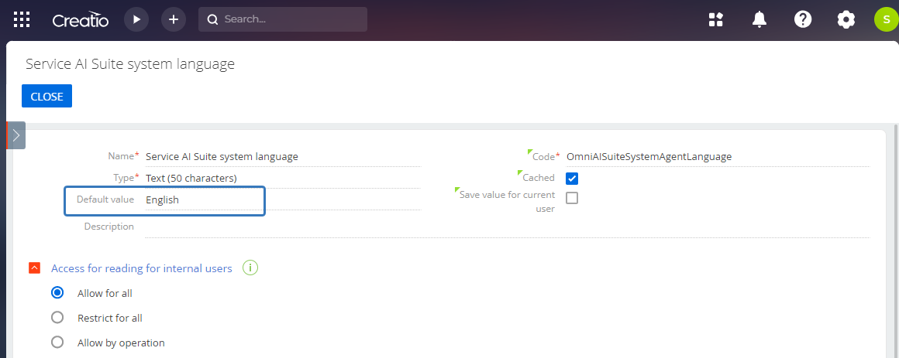

1. Add mailboxes to the automatic translation list

Find the “Automatic translation mailboxes list” in Creatio Lookups. All incoming emails in this mailboxes will be automatically translated to the system native language.

