How to operate module "NOTIFICATIONS FOR CREATIO"

- Go to workspace “General” section “Notifications” to set up notifications for the user.
- Press “ADD” to open main page for creating notification.
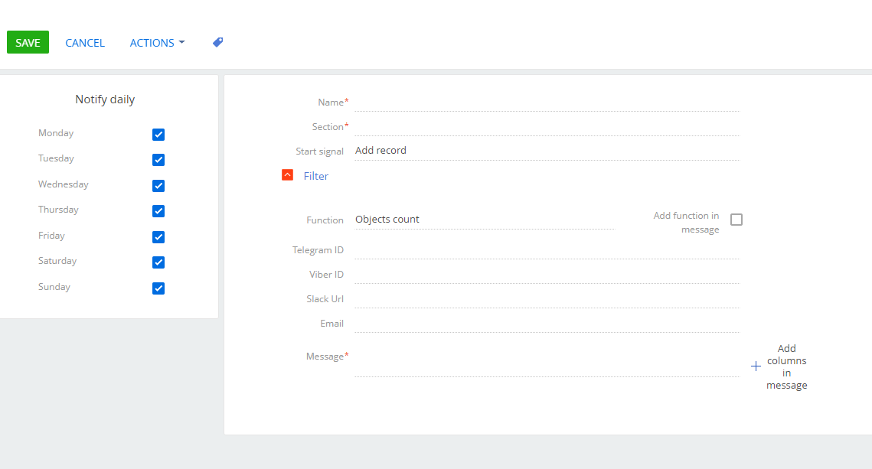
- Name the notification and choose the section of the system you want to get notifications of.
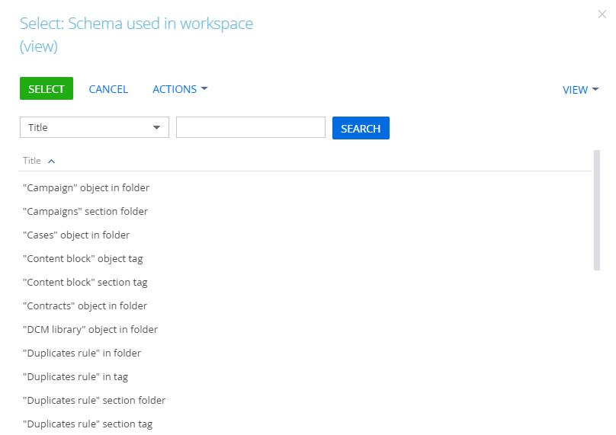

- Select the type of the “Start signal”: add record, modify record or scheduled start. Default value is “Add record”
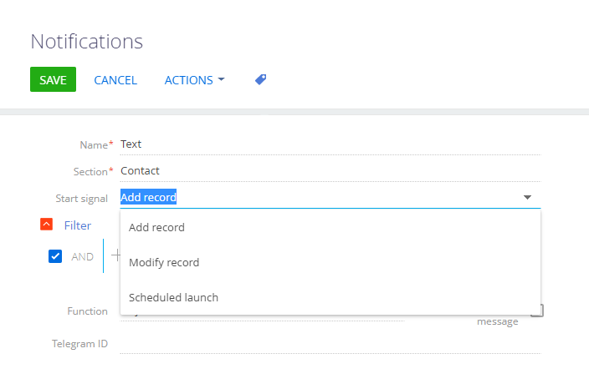
4.1 If you select value “Modify record” you can select what column changes will set up a start signal for the notification in the additional box “Change of”. Default value is “Any column”. User will get notifications of the record change in the selected section.
4.2 User can select multiple columns that will have changes.
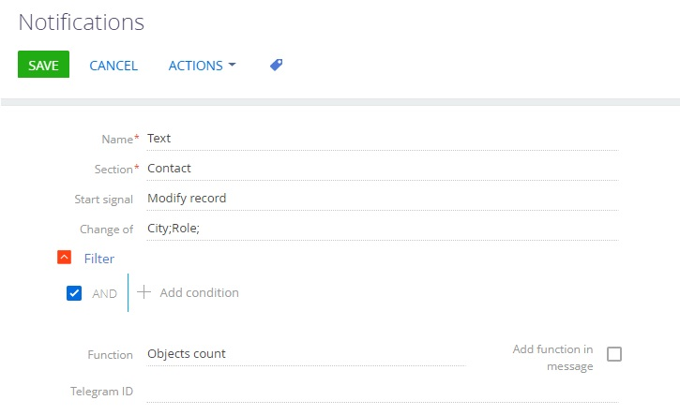
4.3 If you select value “Scheduled start” box “start frequency in minutes” will be displayed. Minimum value is 15 min.
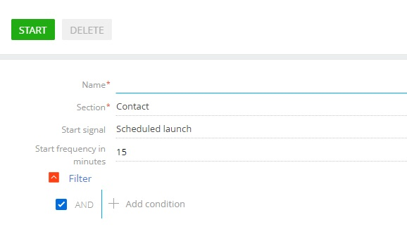
4.4 Press “Start” to run the schedule. The pop-up window will display the text: “Notification scheduled”
4.5 Press “Delete” to remove the notification from the schedule.

- Add one or more columns and their values to filter records. You can select multiple values in the column. Filter applies only on the selected section.
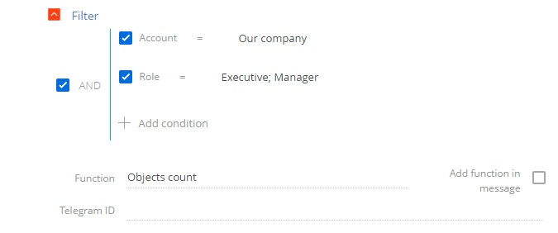
- Mark the checkbox “Add function in message” to get notifications with values: Objects count, Sum of values, Max value, Min value, Average value.
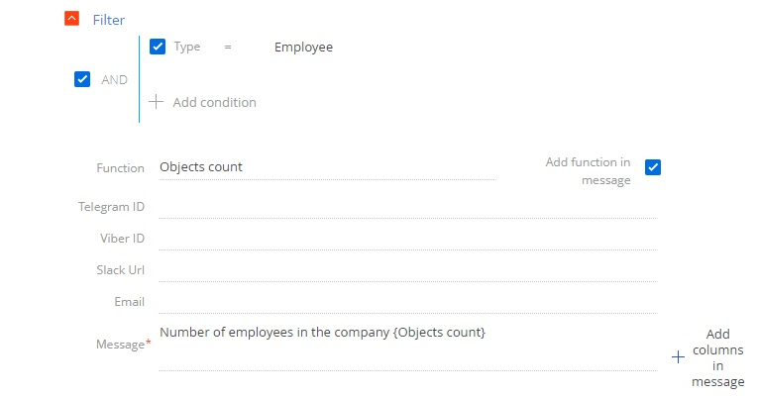
- Fill out the “Telegram ID” box to get Telegram notifications.
Type @userinfobot in Telegram app search and press /start to get your Telegram ID.
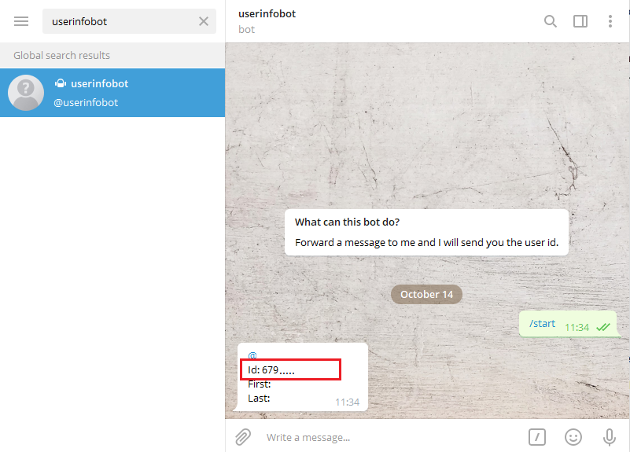
- If you don’t want to fill out your Telegram ID every time you add new notification save your Telegram ID in Telegram contacts list. Next time you can select it using button.
- Fill out the “Viber ID” box to get Viber notifications.
- If you don’t want to fill out your Viber ID every time you add new notification save your Viber ID in Viber contacts list. Next time you can select it using button.
- Fill out the “Slack url” box to get Slack notifications.
11.1 Use only your personalized part of the url. Do not include: [https://hooks.slack.com/services/].

- If you don’t want to fill out your Slack url every time you add new notification save your Slack url in Slack contacts list. Next time you can select it using button.
- Fill out the “Email” box to get notifications by email.
- Choose email from the list or type it.
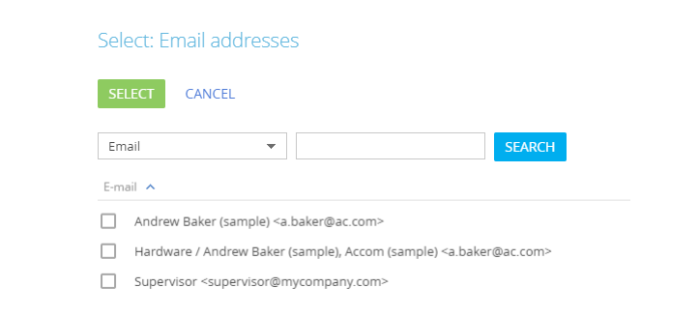
- Box “Message” is a template of your notification where you can type any text you want. Press button 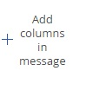to add columns values. Selected columns will be displayed in braces. You can place them anywhere in your text.
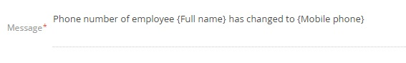
- Select the days to receive notifications in the notification card profile. For example exclude weekends.
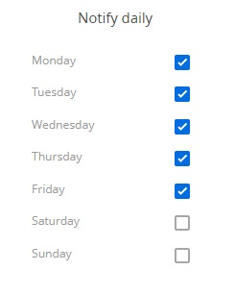
- Use bot token to send notifications to Telegram and Viber.
17.1 Go to System settings to type the value.
- Type the email address in the System settings “Notification email box” to send notifications.
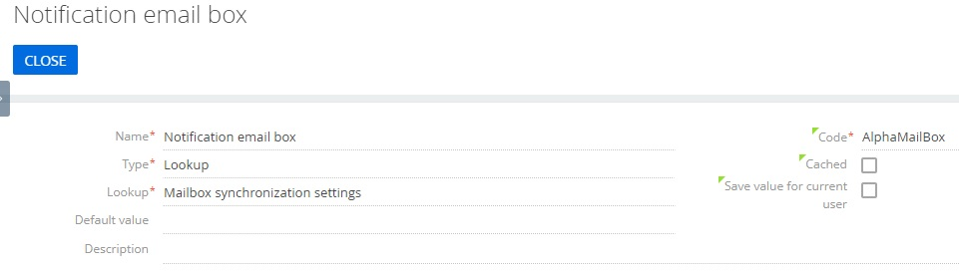

- If you don’t have an access to the Telegram, you can set the value in the System setting “Proxy Telegram notifications” to connect through the third-party server.

